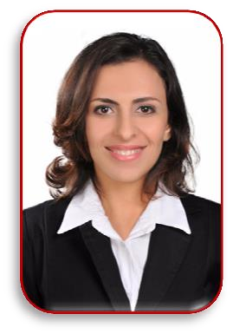
Rowida Mohamed Badr

E-mail: rowaidabadr82@gmail.com
Mobile No: (+2) 01277867793
Address: 39 Elmorsleen Elamrekan-louran , Alexandria, Egypt.

Objective
Seeking a challenging job in a well-established organization where I can make use of my practical business experience and further develop my interpersonal, communication and leadership skills.

Personal Data
- Nationality: Egyptian.
- Date of birth: 01/10/1989
- Marital status: Single

Education:
- Faculty of Literature (graduated 2011)
- Aviation free studies (cabin crew)

Work experience:
- Sales and financial consultant in chubb insurance
- From February to till now
- Sheraton hotel
- Sales from May 2018 to December 2018
- Sky Debt Clinic (Teeth Clinic)
- HR from March 2015 to March 2018
- Sky Dent clinic (Teeth clinic)
- Customer service and call center department from March 2012 to Feb2015
Languages:
- Arabic: Mother Tongue.
- English: Very Good.
- French: Good
- German: student in Goethe institute

Personal Talents
- Ambitious & Self-motivated.
- Hard worker & highly flexibility.
- Able to work under pressure & Multi-tasks.
- Able to
ork individually as well as within a team.
- Excellent in handling with people.

