**ESSALHI SAID**

KSAR EL KANTRA ZRIGAT AOUFOUS ERRACHIDIA

Single

Date of Birth: 03-12-1993

Tel: 06.39.81.49.25

E-mail : [salhisaid830@gmail.com](mailto:salhisaid830@gmail.com)

Driving license (B)

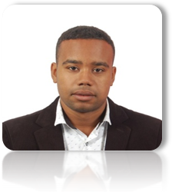



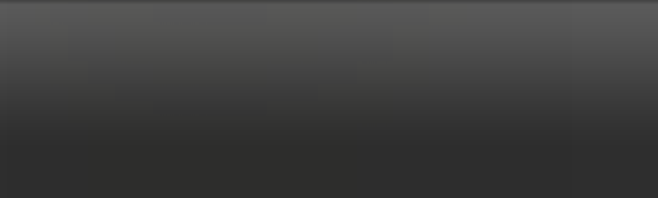

**TITRE DUPOSTE**

**EDUCATION_________________________________________________**

2020  : TEFL from Professional Development Institute

2017-2018 : BA degree major in English language and literature at Moulay Ismail University in Meknes.

2012-2013 : Baccalaureate / High School Diploma in Letters and Human Sciences at Hassan 1 High School -AOUFOUS.

**PROFESSIONAL EXPERIENCE_____________________________**

**2019/2020: Occasional work in the Er-teb Rural Municipality, Errachidia province**

**2016/2019: Certificate of work as an English language teacher.**

**2017/2018: Certificate of participation in computer and computer Basic courses.**

**2017/2018: Internship at Imam Warsh high school in teaching English as a foreign Language in Meknes**

**2018: Certificate of participation: the new sesame complete method of teaching French.**

**2018: Certificate of participation in the training course for the Moroccan Academy of Education and the family.**

**2018: Certificate of formation of a legal, judicial and framing approach by The National Association for Education and Rehabilitation.**

**2018: Certificate of participation in the "Imam Malik" Foundation for Early Education in Meknes under the slogan "In order to better understand and treat adolescents ".**

**2018: Certificate of “using the multiple intelligences Methods to teach young learners”.**

**2018: KOICA certificate "Korea international cooperation agency"**

**2018: Educational training under the title "training as a step towards the development and regeneration of the assisted educational operation" on September 09 and 08, 2018 at the teacher training center in Meknes.**

**2014-2015: Certificate of the English language of club "together as one" in Meknes**

**Computer skills:** Word and Excel

Dynamique ; adaptable ; polyvalent

Les qualités nécessaires aux métiers d’accueil : écoute ; courtoisie ; rigueur

Bonne gestion du temps

**LINGUISTIC SKILLS________________________**

Arabic  : reading, writing, speaking.

English   : reading, writing, speaking.

French : reading, writing, speaking.

**OTHER INFORMATION_________________________**

**Leisure :** Reading, surfing the net, and research.