**Curriculum Vitae**

**Personal Data:**

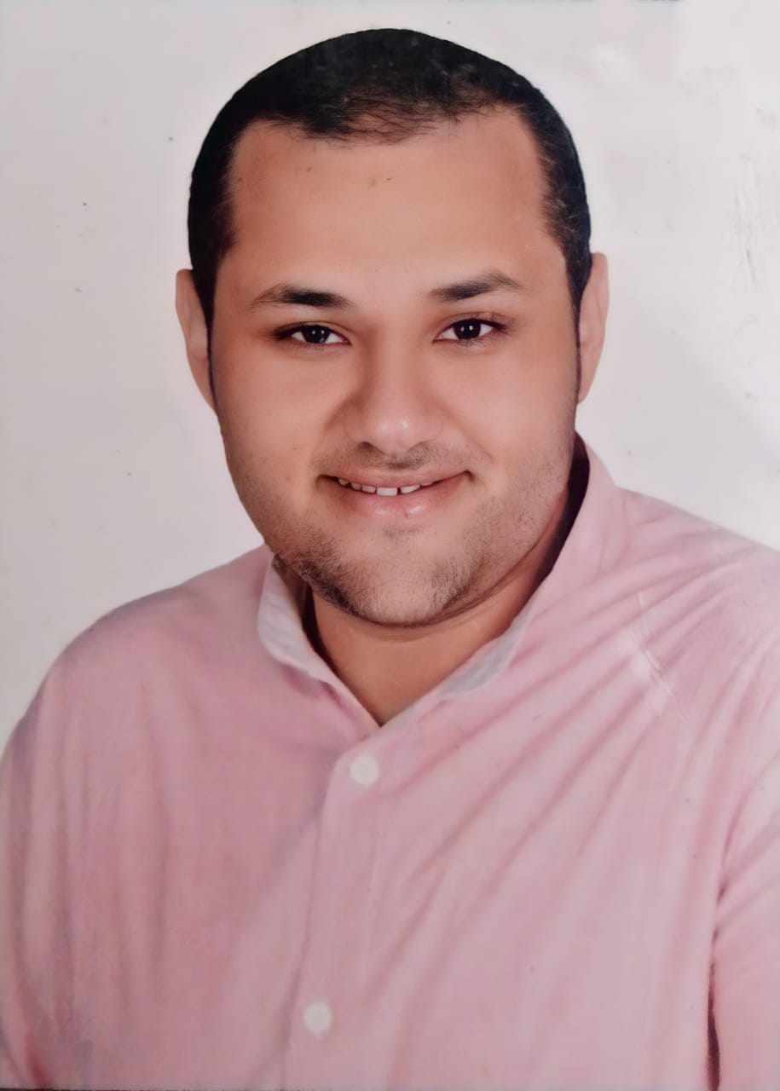

**Name**  : Maged Gomaa Gomaa El-Sisi .

**Gender** : Male.

**D.O.B** :12/9/1988.

**P.O.B** : Rosetta, Behera , Egypt .

**Nationality** : Egyptian.

**Religion** :Muslim**.**

**Marital status**  : single .

**Email** :[**magedlolyyy@gmail.com**](mailto:magedlolyyy@gmail.com) \ **[maged.elsisi.ext@orange.com](mailto:maged.elsisi.ext@orange.com)** .

**Contact:**

**Address** :El-Gomohoria st , Rosetta , El-Behera .

**Mobile Phone** : 01275000768 / 01006785200

**Education:**

* **Name of collage**  : Faculty of Social Work B.S.C .
* **Address of collage** : Alexandria University.
* **General Grade** : Pass .
* **Year of graduation** :2014 .
* **Department** : Psychologist and Social Worker .

**Objective:**

Work in a promising job in the field of my education

to gain experience and promising career.

**Skills:**

**Computer Skills:** Very Good in Microsoft office and internet navigation .

**Language:**

**Arabic** : Native (Mother language)

**English** : Very good command of both written and spoken English

.

**Work experience**

*work in **Private Project ( accessories)** as the sales and marketing managerfrom **2010** till **2018 .**

*work in **Orange** **Company as a** **Customer Service** and **Complain Handling** from **2017** to 1-7-2021

* work in orange company as shop manager from 1-7-2021 till now

**Personal Skills:**

* Ability to work under stress
* Self-motivated
* Ability to learn new tasks quickly
* Per servant in working
* Flexible with working in different time zones
* Good commercial knowledge
* Team orientation