Curriculum vitae

* 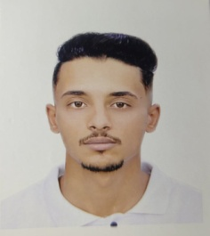
* ***First Name : Mohamed Abdelatif.***
* ***Last Name: Nakmouche***
* ***Date and Place Of Birth: 01/08/1999 à Laghouat .***
* ***Address : City 728 Log / Laghouat.***
* ***Nationalité : Algérienne.***
* ***Téléphone :06.59530884- 06.71421212.***
* ***Driving Licence : Class B.***
* ***EMAIL : [mohamedtech03@gmail.com](mailto:mohamedtech03@gmail.com).***
* ***3 years of expérience.***
* ***Professional Experience and Diploma :***
* ***Senior Technician Electrical Engineering_(Electromechanical)_(Electrotechnical).***
* ***Training Certificate in First Aid .***
* ***Training certificate in HSE (IOSH)***
* ***Professional Experience :***
* ***Certificate of Appreciation / Instrumentation technician “SBN” (JGC) Bossting(HRM3) _ (Installing high tension electrical wires_Installation of electrical transformers _ General Maintenance).***
* ***Business Certificate “ Automated Media Technician In Studies Ofiice ( Hachani Youcef) .***
* ***Business Certificate “Technical Officer “ in Installation of electrical networks and centers (Algerian communications).***
* ***Practical Internship In DML While 15 Days.***
* ***Practical Internship In Sonelgaz ( SPE Hassi R’mel) While 2 Months.(Electric power production station)***
* ***Business certificate Gtp _ electrical engineering (3 month ) installing electrical cabinets - Instrumentation technician .***
* ***Business certificate Ranafor _(maintenance electrical)-(Instrumentation technician).***
* ***Business certificate 3 month Saudi arabia (Nomac)_ Maintenance of pumps, gas and steam turbines, repair of compressors and malfunctions***
* ***Language Mastered :***
* ***Arabe : Excellent.***
* ***French : Good.***
* ***English : Good.***
* ***Others :***
* ***Good physical and moral condition.***
* ***Team spirit***
* ***Free of all engagemen.***