21 Years

Cairo , new cairo , taj sultan city

+2011211115205

Shmostafa673@gmail.com

Shams Mahgoup A long, thin rectangle to divide sections of the document

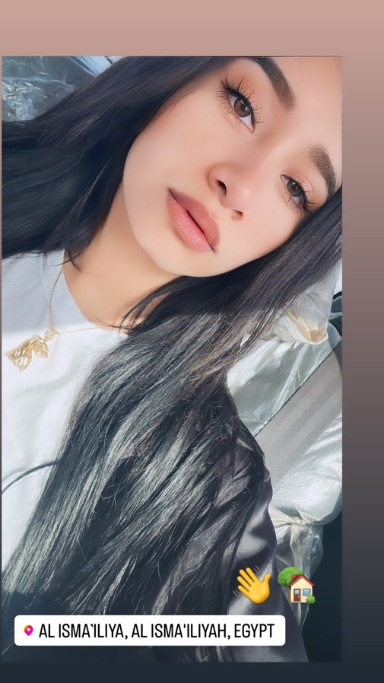

SKILLS

Computer: very good

English: very good

Communication Skills : very good

EXPERIENCE

**Kareem tours , aswan, egypt** *— sales*

From 01/03/2019 to 03/05/2021

**Smash business events, new cairo** *— CEO assistant*

From 22/1/2023 to 7/6/2023

**Egypt vape expo , cairo international conference center** – operation specialist

EDUCATION

**Abu redis secondary school, abu redis ,janub sina** *_ 368,5 degree*

**Studying now at suez canal university, faculty of arts and humanities at physiology apart.**

**. Online marketing course at hubspot**

**. Offline excel course**

**. Offline HR course**

**. Offline English courses**