**Nada Fouad El-Gharieb Mohamed**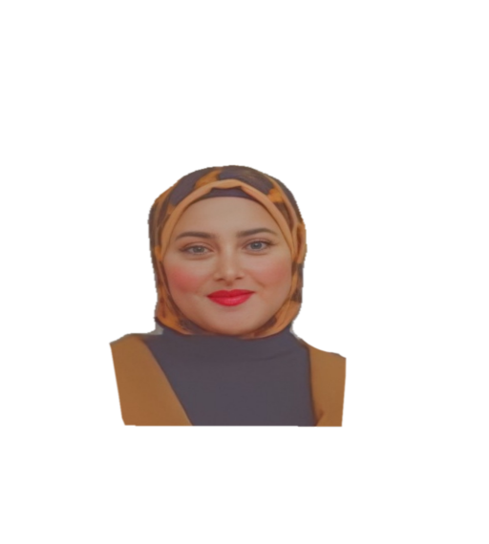

**Mobile : 01094972017**

**E-Mail :** [**hemafouad777@gmail.com**](mailto:hemafouad777@gmail.com)

**Address: Al-Giza, Egypt**

---------------------------------------------------------------

Objective:

To work within atop-calibre organization providing opportunity for growth and career advancement for its employees. To be a part of an organization that has strong core values and will inspire its employees to do well and grow together as one.

Education:

* **Bachelor of Arts , Department of Psychology**

Faculty of Arts, (Ain Shams University)

Courses:

* professional advice workshops
* The skills development program from UNICEF and the Ministry of Youth and Sports
* Human resources Development
* Clinical body language
* Diploma in Clinical psychology Faculty of arts Ain Shams university

**Computer Skills:**

* Microsoft Office
* Word
* Excel
* PowerPoint

**Personal Skills:**

* Excellent communication skills.
* Hard worker and quick learner.
* Excellent presentation skills.
* Adaptability and flexibility.
* Ability to work collectively or individually.
* Ability to work under stress.
* Persuasibility, fluency and ability to make a deep impression on people.
* **Languages:**
* **Arabic:** Mother Tongue.
* **English:** Good
* Interests:
* Poetry
* **Personal Data:**
* **Date Of Birth :**05.06.1998
* **Nationality :** Egyptian.
* **Marital status:** single