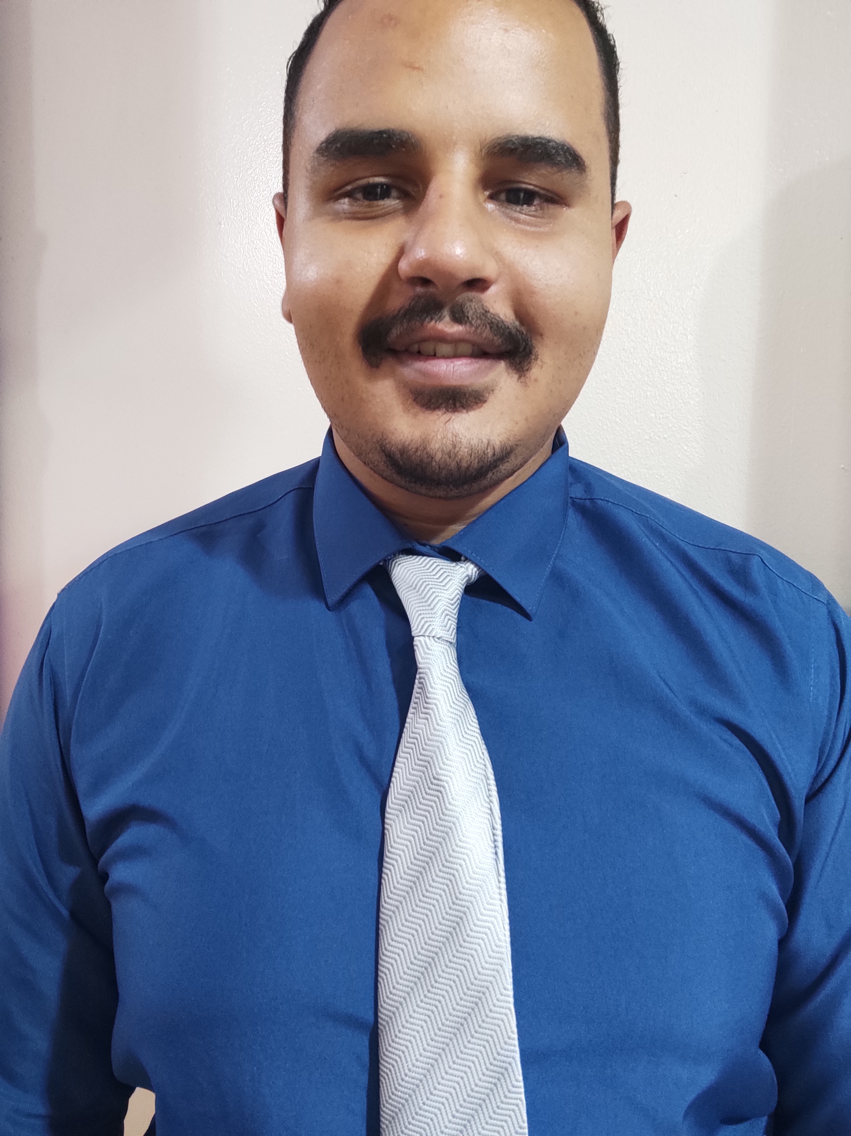 | Saif Yousry Elsayed Hassan  16/01/1999  Abdel Hameed Saeed – El warak - Giza  01110857513  Seifyousry250@gmail.com  Military Status: Exempted
 | Objective
 | Seeking a professional career opportunity in a dynamic & challenging work environment to acquire and build up solid technical and interpersonal skills to be able to become a member of a successful professional team.
 | Education
Qualification : Graduates from faculty of commerce Cairo university May , 2020
Managmnet Section .
Rating : Fair

 | Experiences
 | Oct 2020 – till now : Site Accountant at Redecon constructions
 | Skills
- The ability to prioritize and make on-the-spot decisions.
- Mathematical skills
- Ability to work in a fast-paced environment
- Ability to work well under pressure
- Very good in using MS Word, Excel, power point
- Strong communication skills Organizational skills

