Dear Sir/Madam ,
I would appreciate an opportunity to meet you at your convenience for a personal interview, so that we may Discuss in greater detail how my qualification may be of mutual benefit. Thank you for your time and consideration. I look forward to hearing from you in the very near future.

Demiana SAMY FAHMY
Address:
1, 15 st right from 45 st (Anwar el-sadat Street) / el-Asafra Qebly
/ Alexandria / Egypt
Telephone:
(+2) 03 - 5351676
Mobile phone:
(+2) 01285111840
E-Mail:
lucywanas2@gmail.com

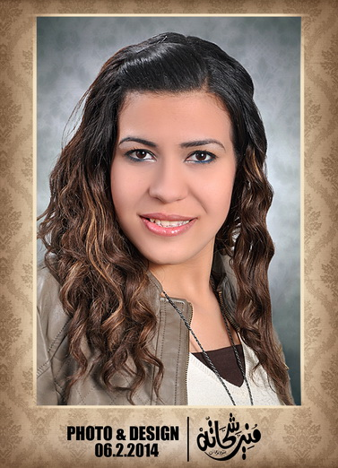

Objective

-To be hired as a Human resources

Personal data

Name | : |  | Demiana Samy Fahmy
Date of Birth | : |  | feb.,9,1990
Resident of Birth | : |  | EGYPT
Marital Status | : |  | Mired
 |  | :

Education

Preparatory School | : |  | Franciscan Fathers Sedi-Bishr Prep School / Alexandria
High School | : |  | Mealy elsiof - Secondry School andria
University | : |  | Alexandria University /Egypt
College | : |  | Faculty of touism and hotel Alexandria
Graduation Year  Postgraduate. : |  | : |  | May-2011  Diploma Educational Annum may 2012.  Magisterial in Psychology study now.

Language skills

- Arabic | : | Mother Language
- English  - Français : | : | Very good ( speaking, listening, reading and writing )  Good. (Speaking,writing and reading )

Computer skills

- ICDL Certificate (S/N EGY2001187).
- Maintenance of Hardware and Software.
- Excellent on Surfing, browsing the internet and Network Connections.

Work experience

- working a Human Resources in leaders language school from 2015 to 2022

- working a Deputy Head of Human Resources in future rise language school from 2022 till now.

Personal Skills

- Good interpersonal skills and commitment to service - Ability of working under pressure.
- Desire to win and succeed in any scenario - Work individually or in teamwork.
- Enthusiastic ambitious worker. - Attention to detail
Thank you for taking the trouble of reading this document
References available upon request

