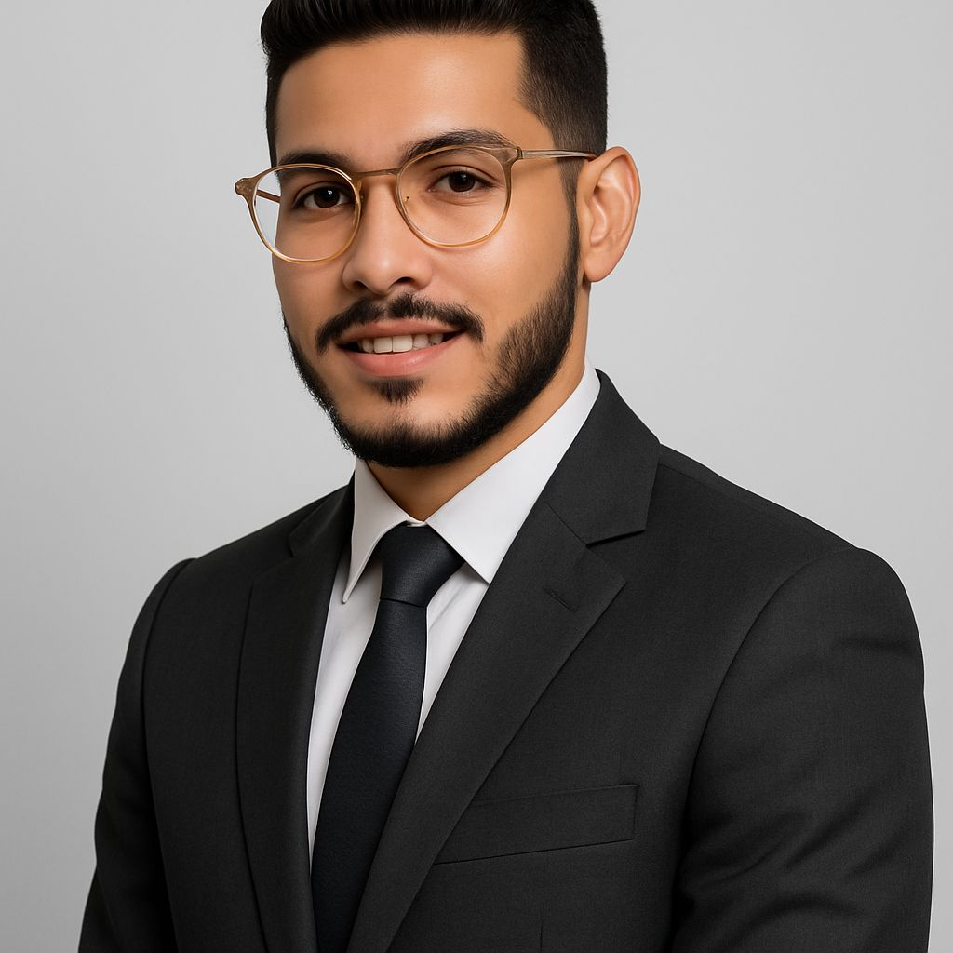Abdelhady Nabil Ahmed Ahmed

* Phone: +201278424171
* Email: nabilhady11@gmail.com

# Professional Summary

* Dedicated HR professional with experience in administrative support, employee relations, and internal communication. Proven ability to handle responsibilities independently and maintain confidentiality while managing multiple roles. Skilled in recruitment, documentation, and problem-solving with exposure to international coordination.

# Work Experience

* HR Specialist – Three Stars Fashion  
  Duration: 5 months (Ongoing)  
  - Built strong relationships with workers and maintained ongoing communication to enhance their efficiency.  
  - Managed complete worker files, including personal documents, standard forms, and legal paperwork (Form 1 & 6).  
  - Oversaw the fingerprint attendance system and ensured accurate time tracking.  
  - Responsible for labor sourcing and employee retention strategies.
* Assistant General Manager – Xcira Company  
  Duration: 1 year  
  - Scheduled and organized all appointments for the General Manager.  
  - Maintained strict confidentiality across all communications and internal operations.  
  - Acted as a liaison with the company’s headquarters in China.  
  - Handled internal administrative challenges and represented the GM in his absence.  
  - Managed relationships and internal workflow across departments.

# Education

* Bachelor of Law – Alexandria University  
  Start: July 2018 – End: June 2022 | Final Grade: Good  
  Military Service: Completed

# Courses & Certifications

* - Human Resources Management – Edraak (Online)  
  - Body Language – Edraak (Online)  
  - Personal Development – Edraak (Online)  
  - ICDL – Alexandria University

# Skills

* - Strong interpersonal and communication skills  
  - Creative, self-motivated, reliable, and dynamic  
  - Able to work independently and in a team  
  - Able to work under pressure  
  - Computer proficient: Microsoft Office (Word, Excel, PowerPoint), MOS Certified

# Languages

* Arabic – Native  
  English – B2 Level

# Personal Information

* Date of Birth: 25th November 1999  
  Marital Status: Single  
  Nationality: Egyptian  
  Military Status: Completed  
  Religion: Muslim  
  Additional: Athlete, well-groomed appearance