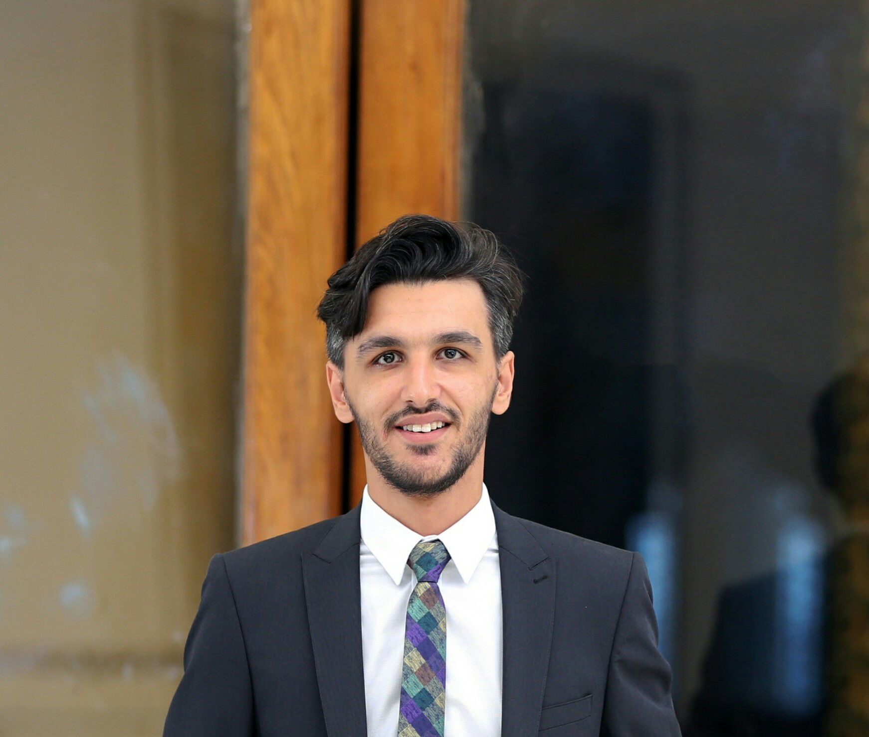 Hamdi EBRAHIM HAMDI EBRAHIM













Al Arish

North Sinai, Egypt

Hamdyelkashef26@gmail.com

+2 01026332769

CIVIL Engineer

**Sinai University**

**Graduated at May 2018**

**Grade**: good(2.4)

**Graduation project: Foundation**

**summery:**

Civil engineer with 4+ years’ experience. I worked in many projects as a Site engineer.

I have gained my extensive experience in *CAD Design* using AutoCAD, SAP 2000 and ETAP.

I have gained my extensive experience in the field of *PMP* using Primavera and Excel.

I am available to work off-shifts and weekends, individually or among teams.

**Career Experience:**

* **October 2013 – October 2014 3rd Civil Engineer**

**North Sinai General Directorate of Ground Water.**

Ministry of Water Resources & Irrigation.

* I was a supervisor of many Projects in Sinai Government.
* I was a supervisor of drilling 8 deep underground wells with depths of ±1200 meters.
* I involved in building *Talet El Badan* Dam to protect *El Hasana* city from the danger of torrents.
* I involved in building *Abu Triva* Dam to protect *Nikhel* city from the danger of torrents.
* I was a member in many financial and technical committees.
* **October 2014 – August 2016 Site Engineer**

**Arab Contractors Company.**

* I involved in building *El Safa* water tank In *Al Arish* City (Capacity of 3000 m3)
* I worked as a Site Engineer in the field of roads and bridges in *Al Arish* City.
* **December 2016 – July 2017 Site Engineer**

**Sina Sons Company for Constructions.**

* I involved in building *Rafah* Land Port.
* I involved in building *Gif’gafa* Factory of Marble in the Middle of Sinai
* **September 2017 – May 2018 Site Engineer**

**Gamal Atia Company for Constructions.**

* I involved in building Social Housing Project In *El Sapil Area* In *al Arish* City.
* **June 2018 – Present Site Engineer**

**Abo El Makarem Company for Constructions.**

* I involved in building *Sakan Masr* Project in *Fifth Settlement* City in *Cairo*.

**Courses:**

* **May 2012 ICDL**

Under the supervision of Dr. Hassan Kandel.

* **February 2015 P.M. P (Project Management Professional course).**

At *Becom* Academy

* **March 2015 Modern Surveying Instruments course**

At *UNESCO*.

* **November 2015 AutoCAD 2D Course.**

At Arabic Center for Training.

* ***I have attended many conferences and lectures that related to Constructing science and technologies.***

**Skills:**

* **Language:**
* Arabic: Mother Tongue.
* English: Very Good spoken and written.
* **Computer:**
* **AutoCAD**
* **SAP 2000**
* **Primavera**
* **Adobe Photoshop.**
* **Good command of Microsoft Office applications (Word – Excel - Power point).**
* **ICDL.**
* **I have the ability to learn, quickly, any program or have any skills.**

**Field of interests:**

* Executive engineer of different structures
* Sanitary work Engineer
* Inventory quantities engineer

**Personal Information:**

* **Date of birth: July.11.1993**
* **Nationality:** Egyptian.
* **Marital state:** Single.
* **Military state:** Exemption.