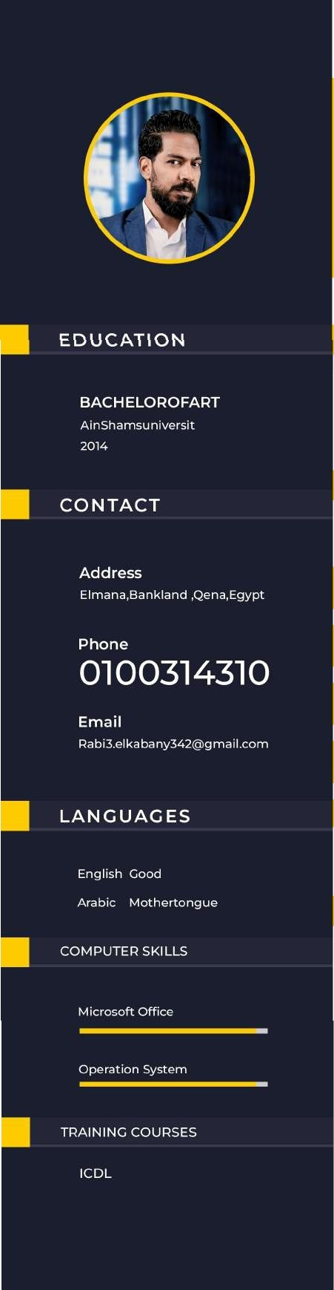

MOHAM ED RABEI

ELKABANY

S A L E S P R 0 F E S S 1 0 N A L

# ABOUT ME

I am Mohamed Rabie, with more than ten years of sales experience. I have the ability to sell under any circumstances

# WOR K EXPERI ENC E

MARKETINGAND SALES ELECTRICS APPLIANCES RAYA COMPANY APPLICATIOH MAZAY FROM 3/1022 TO NOW

WORKED BRANCH MANAGER INBRANDSHOP SAMSUNG QENA HOMEA?PLIANCES FROM 4/2021 TO 3/2022

5

AREA SUPERVISOR IN HUAWEI MOBILE.

FROM 3/2020 TO 4/2021

SALES IN II\ITERNATIONAL COMMUNICATION EGYPT I2

FROM 5/2017 TO 3/2020 SALES IN X MOBINIL FROM 1/2007 TO 1/2011

# EXTRA SKI LL5

ABILITY TO WORK WITHIN A TEAM WITH MERIT ABILITY TO0 RGANIZE TIME AND SETP RIORITIES

ABI LI TY TO WO R K UN DE R P RESSU RE

ABILITY TO TRAVEL AN0 NAVIGATE AT ANY TIME

ABI LITY TO WO RK AS SH ORT AS POSsi BLE