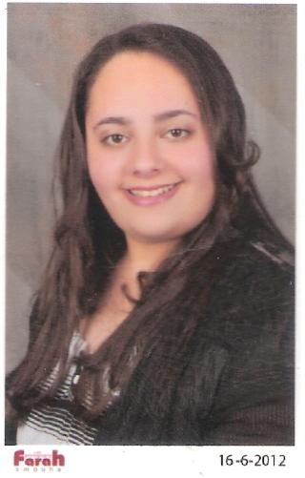**Curriculum Vitae**

***Name:*** *Mariam Farid Zarief*

***Date of Birth:*** *6 November 1990*

***E-mail:*** *mariam.farid50@yahoo.com*

***Contact Information***

***Mobile :*** *01001479278 – 01212538787*

***Home :*** *0244785694*

***Address:*** *103 Compound Dar Masr , fifth floor, El-Obour , Cario.*

***Qualifications:***

*B.SC ( Financial & Customs Studies ) in MAY 2011, Alexandria University, Faculty of Commerce.*

*(* ***Grade:*** *Good )*

***Previous Experience:***

* *work at Tourist company as sales indoor for a month .*
* *work at Health and Safety Filter company as telesales for a month .*
* *work at E.M.K medical company as data entry for 4 month from ( 1/11/2011 to 31/3/2012).*
* *work at Galina Agro-Freeze company as marketing and export specialist for 3 months from ( 1/6/2012 to 30/8/2012 ).*
* *work at Adam company for recruitment abroad for 5 months as secretary from*

*( 1/12/2013 to 30/4/2014 ).*

* *work at Misr Industrial Supplies company as executive secretary from (1/6/2014 to 31/12/2019 ).*
* *work at O&J clothes shop as sales employee for 3 months from ( 1/10/2021 to 31/12/2021 ).*
* Work at Rose optics shop as sales employee for a year till ( 31/7/2023 ) .

***Education:***

* *El-Manar Language School and EL-Zahraa Language School.*
* *Computer ( Icdl ) and English is first language and then Arabic .*

***Certifications:***

*( Mini MBA )*

* *Training Diploma in Amadeus Basic Course with degree(A) from Alpha Aviation Services .*
* *Principles of Banking certificate from ( 2/6/2012 to 3/7/2012 ), Total hours: 100, from Bank of Alexandria.*
* *Accounting Practice in English (1), Financial statements and The Accounting Cycle from ( 4/9/2011 to 28/9/2011 ) from Faculty of Commerce, Alexandria University.*
* *ICDL(It-Windows-Word-Excel-PowerPoint-Access-Net), Innovation Center , Grade: (A).*
* *Diploma in General English from (15/2/2012 to 15/5/2012) from The International British Academy (IBA), with Degree: Excellent.*
* *Advanced Diploma in General English from College of Cambridge with Grade: (B).*
* *International Computer Driving License in the computer services center from The Arab Academy for Science & Technology.*

***Soft Skills:***

*Willingness to learn , Commitment , Dependability , Team Work , Co-operative , Desire to achieve , Flexibility , Adaptability , Time management , Can cope with pressure & stress .*