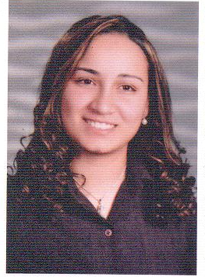
Mariana Samy Ayad
Personal information:
DOB: 5th of October, 1986
Place of birth: Alexandria
Address: 15 Malak Hefny st. Victoria
Mobile: 01227081258
Email: marianasamy86@gmail.com
Personal statement:
I am a self confident, enthusiastic with a strong creative background. I have the ability to work with a team 100% focused on maintaining standards, achieving goals.
Languages:
- Fluent English 2- Good French 3- Good Greek
Education:
- 2018, Got the "PHD" from Faculty of Arts "Institute of Coptic Studies" Alexandria University
- 2015, Got the "Master Degree" from Faculty of Arts "Greek and Roman Archaeology department" Alexandria University
- 2009, Got the "Bachelor of Arts" from Faculty of Arts "Greek and Roman Archaeology department"
- 2009, Got "ICDL Certificate" from "Step To The Future"
- 2005, Got the "High school certificate" from "El-Nasr Girls Collage ( E.G.C )
- Free Lectures at "Bibliotheca Alexandrina" (Body Language, CV writing, Time Management and Professional Communication)
Computer skills:
- Excellent command in computer skills.
Hobbies & Skills:
- Arts work 2- Photography 3- Event Planning 4- Travelling
Training Experience:
- 2017, Teaching skills "College Notre Dame De Sion"
- 2016, Training course "study of an ancient city" at "Marina ancient city El- Alamein"
- 2009, Tourist Guide training at the " Alexandria Museum "
Work Experience:
- Customer Service at "Macro German Company" for two years
- English Teacher at "College Notre Dame De Sion" for four years
- Assistant Office Manager at "Monochem Company for Medical Suplies " for three years
Thank you for your Time

