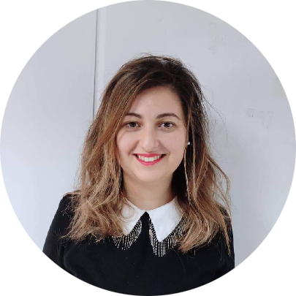

MOUFIDA

KHOUALDIA

Sales Manager

E: moufidakhoualdia93@gmail. com

P: 0561633225

A: Dar El Beida, Algiers

Driving License:

License B

Date of Birth:

07/03/1987

SKILLS

Team spirit

Rigor

Redaction

LANGUAGES

French

English

Arab

# PROFILE

Sales Executive

# EDUCATION

**Bachelor** Degree of Vegetal Ecology and environment | USTHB, Algiers

2005 - 2008

Dalf C1 | Algiers French institute, Algiers

2011

**Master** degree in language Engineering and industry | Polytechnic university, Bucharest - Romania

2011 - 2013

**Master** degree Lea Corpus bioinformatics | Paris Diderot university

2014 - 2015

**Master** degree on French didactics-second foreign language | Sorbonne University , Paris

2014 - 2015

Merchandising training certificate | IMS international research

2017

# EXPERIENCE

Commercial Agent | ACF Nation , Paris-France

2014 - 2015

* Schedule management of teachers
* Fist point of contact for clients
* Head of communication with the prefecture Identity and access management
* Administrative management

Commercial and Marketing Manager | Océane Center Spa , Algiers

2016 - 2017

* Oversee the sales Team
* Prepare the financial offers for potential clients Collaborate with the Marketing Team
* Handle Admin procedures Collaborate in collection and payment

Sales Executive | Océane Center Spa, Algiers

2018 - Present

* Commercialize location spaces of City Center mall
* Negotiate the financial offers and terms with potential clients
* Ensure the follow up of rental agreement
* Collect the monthly turnover of operators
* Maintain the tracking data of visitors and analyses statistics of visitors
* Ensure support to operators within the mall
* Run promotions and events inside the mall in order to boost the client footprint.