|  |
| --- |
| **Mahmoud Gomaa Mahmoud Mustafa** |
| 23El Emam El Shafeay St - El Khalifa- cairo |
| Mobile: ( +2 ) 01007400066 |
| Mobile: (+2) 01060184596 |
| E-mail: [mahmoud](mailto:mgomaa01@outlook.com)gomaa949@yahoo.com |

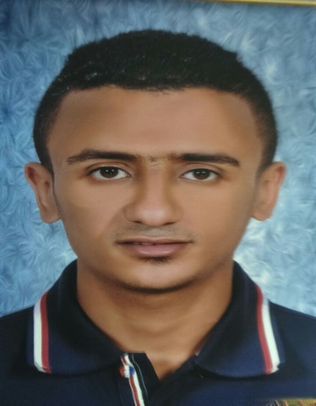

**PROFILE:**

An ambitious person who is seeking for a good job that meet my skills, knowledge, qualifications and previous experience that will lead me to my desired career.

**ADDITIONAL INFORMATION:**

Date of Birth: 5/01/1991

Nationality: Egyptian

Military Status: Exempted

Marital status: Single

**EDUCATION:**

|  |  |  |
| --- | --- | --- |
| 2007 - 2011 | **I graduated from Cairo Higher Institute of Languages ​​and Interpretation**  **Average grade:** Fair. | |
|  |  |

**Work Experience:**

**2009 -2012 Sales at Terranova**

* Analyzed and properly processed product returns, assisting customers with finding alternative merchandise to meet needs.
* Recommended accurate and effective solutions to customers after identifying problems.
* Built strong rapport with clients by understanding needs and clearly explaining products.
* Check inventory to ensure product is in stock.

**2013 -2015 Sales at Bee**

* Handling clients and potential clients to evaluate needs or promote products and services. face to face
* Attracts potential customers by answering product and service questions; suggesting information about other products and services.
* Opens customer accounts by recording account information.
* Maintains customer records by updating account information.
* Answering client questions about credit terms, products, prices and availability.
* Maintaining client records.
* Coordinating sales efforts with marketing programs.

**2015-2016 Sales Manager at H&M**

* Manage the sales team to achieve the target
* Achieve growth and hit sales targets by successfully managing the sales team
* Design and implement a strategic business plan that expands company’s customer base and ensure it’s strong presence.
* Own recruiting, objectives setting, coaching and performance monitoring of sales representatives
* Build and promote strong, long-lasting customer relationships by partnering with them and understanding their needs
* Present sales, revenue and expenses reports and realistic
* Promote, specify & sell the full range of interior and exterior cladding
* Searching and dealing with mega projects.

**2016-2018 Sales Manager at Landmark**

* Manage sales operations in the assigned district to achieve revenue goals.
* Supervise sales team members on daily basis and provide guidance whenever needed.
* Identify skill gaps and conduct training to the sales team.
* Work with the team to implement new sales techniques to obtain profits.
* Assist in employee recruitment, promotion, retention and termination activities.
* Conduct employee performance evaluation and provide feedback for improvements.
* Contact potential customers and identify new business opportunities.
* Stay abreast with customer needs, market trends and competitors.

**2018-Present Sales Representative at Concept Real Estate**

* Run calls and target calls to generate business opportunities from assigned leads.
* Determining clients needs and financial abilities to propose solutions that suit their needs
* Be a consultant for the buyer by advising clients on market condition and market investment opportunities
* Facilitating the process of buying a property by making a comparison between different projects
* Be a link between buyers (Property Development Companies) and sellers
* Hold visits for the customers at the of different projects locations.
* Maintain an ongoing relationship with the customers by following up on their requests and updates through accurate feedback entry on CRM.
* Following up with the partners (Property Development Companies) to get updated availability.
* Following up with the management to ensure fast and high-quality communication to organize and archive work outcomes
* Looking for an ambitious and hard-worker agent to work at the top Real Estate brokerage company all over Egypt.
* Working with the top developers in the real estate market in Egypt .

**GENERAL SKILLS:**

**Language:** Arabic “Native” English: Good

**Computer Skills:** Microsoft office skills, and Interne

**Personal Characteristics:**

* Quick learner in case of new material and knowledge.
* Good communication, presentation, and Problem solving skills.
* Able to handle work stress and meet deadlines.
* Capable of working successfully in collaboration, teamwork and individual.
* Creative and self-motivated.

**COURSES ATTENDED:**

**May 2014** .Soft Skills and Organizational Behavior Training