Personal Information
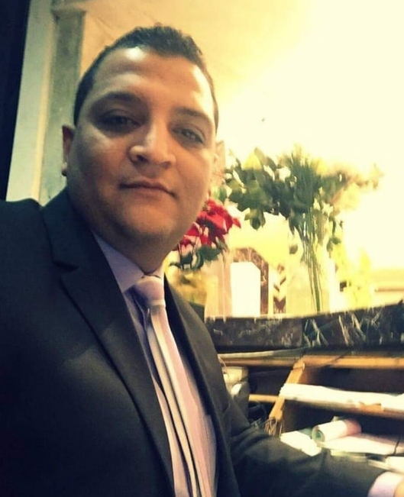
Name : Mohamed Atef Abd Elaziz
Date of birth : 01/01/1990
Nationality : Egyptian
Marital Status : Married

Contact Information
Address : 6 Suleiman Mohamed Saad Street, Hadayek Alquba.
City : Cairo
Country : Arab Republic of Egypt.
Phone : 01226442425
Languages
- Arabic (العربية) :
- Read : High proficiency.
- Write: High proficiency.
- English:
- Speak : (good)

Computer Programs:
- Internet explorer (good).
- Microsoft project (good).
- Microsoft office(good)
- Word (good).
- Excel (good).
- PowerPoint (good).
- Photoshop (good).
- Googel (good).
Certificates
- The Higher Institute for Advanced Studies - Al-Haram

Previous experience
- House of the Engineering Authority of the Armed Force
( Accounts and sub-treasury department at Aldar )
From 15/6/2013 - To 07/12/2020

- EL AFIFI Expertise House Of Engineering Consultant Cairo, Egypt
From 01/08/2021 To Until now

