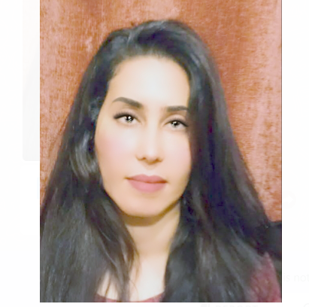

**Name**: Noha Fawzy Abdelkhalek Foda

**Nationality** :Egyptian

**Place of birth** : Cairo

**Mobile**: 01099426630

**Date of birth** :1/11/1985

**E-mail**: Nohafoda36@yahoo.

**Education**:

Specialized in accounting and management / at Cairo university.

**Experience**

|  |
| --- |
| **Sales**   * Worked as sales and Marketing at ( San George Hotel “ 2010-2012") * Worked as sales and Marketing at (Holliday village Hotel “ 2012-2013") * Worked as Sales and Marketing at (CLEOPATRA Hotel 2014-2015") * Worked at sales and marketing at (JOLIE VILLE CONFERENCE HALL “ 2015-2018")   **REAL ESTATE MARKETING**   * Worked as General Manager at (REAL PERIPORITY Company "2018-2019")   **Accounting**   * Worked as accountant at ( American daily- system , and revision of the accounts "2019-2020")   **Social media**  Worked at (Dalil masr) company and at (Social Media Services) from 2020-2022. as the below   * Digital marketing services * Facebook ads * Websites marketing * Google ads/ new techniques of digital marketing * Media communication/ audio and video ads… they are used to target the audience * Design of Commercial signs * Design of the websites * Preparing of internet browsers/ marketing of the websites that’s known by the service of preparing of searching browsers (SEO) * SMS/ Marketing service via (sms) and sending a commercial short message in order to attract the costume and the new clients * Srategy of attraction the active followers and the Management of complete marketing campaigns (digital marketing) * Planning and prices * Improvement of the arrangement of searching browsers * Documentation of facebook pages * Increasing the followers of (facebook- youtube- instagram-tiktok-) |
|  |
|  |
|  |
|  |
|  |
|  |
|  |
|  |
|  |
|  |
|  |
|  |