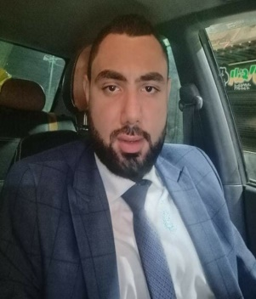

**Mohammed Ali Ebrahim Ali Allam**

1. PERSONAL DATA:

* Date of birth : 03 - 07 -1992
* Address : Ayat - Giza
* Email Address : mohamedallam348@gmail.com
* Phone No. : - Mobile No. :01009409590
* Military status : Final exemption

sociall Status : unmarried

1. EDUCATION & QUALIFICATIONS**:**

* Rights License, Faculty of Rights cairo University.
* Year 2013
* Overall Grade: Good

1. WORKING EXPERIENCE**:**

| **Employers Name** | **Location** | **Job Description** | **Duration** |
| --- | --- | --- | --- |
| Marketing and Trading | Giza | Different Marketing and Trading tasks | 2014 to - 2016 |
| El Huda company for Poultry | Giza | In charge of Administrative , technical works | 2016 to -2022 |

1. Job Assignments**:**

* In charge of labors.
* Organizing equipments maintenance weekly courses.
* Preparing technical reports about equipments status.
* Making sure that the equipment working properly before using.
* Pursuing hiring technicians and training them.
* Pursuing seizing disbursements and control budgets.
* In charge of Documentary session.
* Monitoring stock of spare parts and equipments.
* Pursuing purchasing spares and other material .

1. SKILLS:

* **LANGUAGE SKILLS:**

-Arabic: Native Language.

-English: Good

* **COMPUTER SKILLS:**

- Windows

- Internet

-Microsoft Office (word - excel - PowerPoint - access)

- I C D L

1. Courses :

- good English skills

1. Hobbies :

**Watching football matches.**