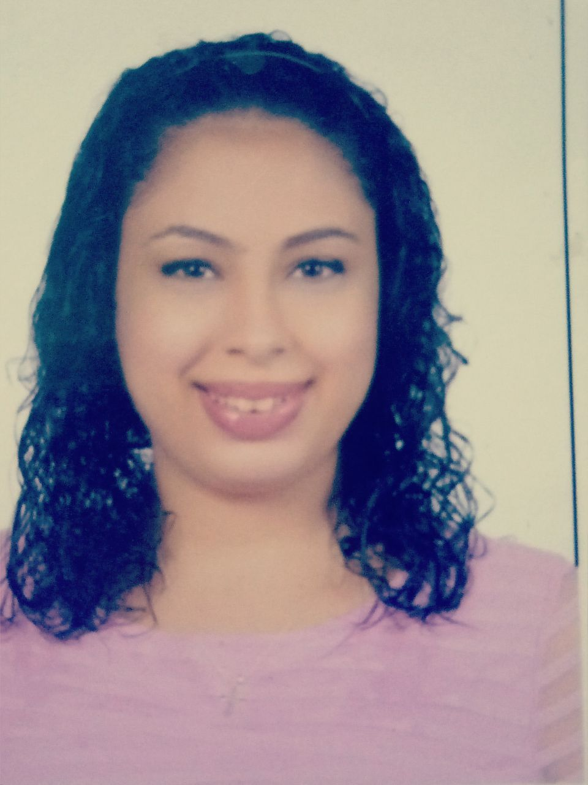

**Merit Fady Aziz**

## Personal information

* Date of Birth: 25/3/1995
* National ID : 29503250104023
* Marital Status: Single
* Mobile No.: 01205282763
* Address: 36 st -Mohamed abo El naga -faysal- Giza

**Objective**

Ambitious to find a good job suitable with my Life to achieve my goals.

**Education**

* High School

Graduate from Tourism & Hotel management.

* Helwan Universty

**Skills**

**1- Computer skills:**

* Excellent knowledge of M.S office (word, Excel, PowerPoint, access).
* Windows Xp.

**2- Language skills:**

* Native language Arabic.
* English : Good command of both written and spoken.

**3- Social Skills**

* Ability to work in a team.
* Self Motivated.
* Perform Multitasks in one time.
* Reading.

**Experience:**

* Training in Misr Travel for one month.
* I have experience amadaious system .
* Training in travel design Egypt and comprehensive tourism training
* 3- geography of Egypt
* 4- product knowledge
* 8- business etiquette
* 9- personal skills ( positive attitude & efficient time managemen
* I'm working Tele sailes in voudafone company.

■I’m working Reception in marmina hospital