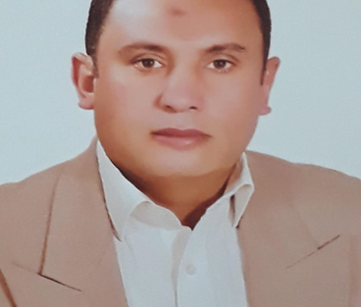

* **Name : Mohamed Ibrahim Mohamed**
* **Date of Birth : 4/4/1975**
* **Job Title : Boiler Supervisor**
* **Mobile : +201021585738**
* **Military Service : No Service**
* **Address : EGYPT / City Bard**
* **Car : yes**

**Marital status : Married**

**Industrial high school 1993**

**Specialty / Metal Welding**

* ***Currently the*** ***Utilities Technician 1 at Pfizer Egypt f- 12/2016*  until now**
* **Operation and maintenance of boilers &Operation and maintenance of reverse osmosis water plant****&Air Compressor&Building Maintenance**
* ***Company / Sunny Pharm from 2009-2016***
* **maintenance** **supervisor:** **Operation and maintenance of boilers &Operation and maintenance of reverse osmosis water plant&Air****&** **Nitrogen generator and oxygen generator****&Air Compressor**
* ***Best of France Lacteal : 2-2009007***
* **Operation and maintenance of boilers&Air Compressor** 
* ***Company******Al Rashidy Al Mizan (Food) 2005-2006***
* **Operation and maintenance of boilers**
* ***Company*** ***Universal cellulose production and derivatives:2000-2005***
* **Utilities supervisor:** **Operation and maintenance of boilers& Nitrogen generator and oxygen generator&Air Compressor&Chiller and cooling towers**
* ***Company*** ***Nour Midas Textiles:1996-2000***
* **Operation and maintenance of boilers** **Steam, oil, hot water, super heater, welding and maintenance**
* ***Company*** ***Electromica for power plants:1994-1996***
* **Pellet welding**

* **Course in.TIG WELDING LEVEL ONE**
* **Course in Chemical cleaning for RO Systems.**
* **Course in Water Desalination**

**Course in Reverse Osmosis**

**Course in** **Boiler water treatment and cooling towers**

* **Projects have been implemented**
* **Steam lines with a length of 80 meters operating pressure 8 bar**
* **Compressed air line operating pressure 7 bar**
* **Start up** **for boilers (6 tons & 3 tons & 25 tons per hour**
* **Hydr steam operating pressure 10 bar**