CURRICULUM VITAE

Esraa Ahmed Mustafa

Tabark Boreg tabark street - Miami

Alexandria

Egypt

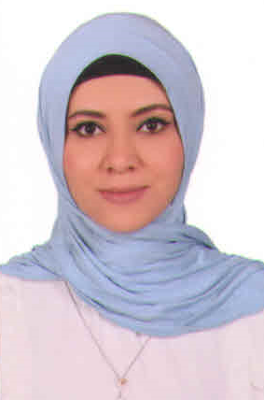

**D.O.B : 31 – 03 – 1989**

**Tel: 03– 5539305**

**Mob : +201011412777**

**E-mail : esraamoheb.em@gmail.com**

**A self-Motivated ,Good Communication Skills The ability to Use Own Initiative to Achieve Personal and Work Related *Targets .***

* **Skills / Achievements :**
* **Very Good in English**
* **Confident When Communicating .**
* **P.C Literate**
* **Good Team Player**
* **Determined and Effective Under Pressure**
* **Problem Solving**

**Qualifications Achieved :**

* **BSC. Management Information System .(2009)**

**Computer Skills:**

* + **Certification ICDL (2008).**
  + **Certification with C# (2008).**
  + **Programmer with C# (OOP) .**
* **Database programming with Access and SQL Server.**
* **Work Experience:**
* **Al dora Company Programer**
* **Customer service at WE zezenya Branch from 2011 To 2018**
* **IT at Mosahmet El Behera company 2019**
* **Customer service at Dr Karem Aly website 2020 From Home**
* **Khalil pharmacy, internal department 2022**