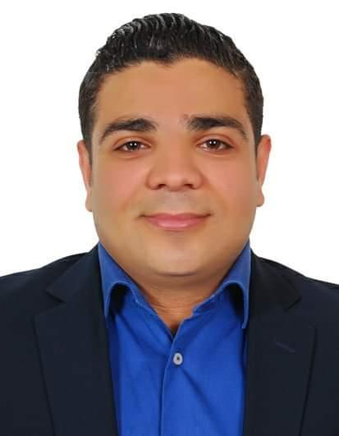

# Ahmed Samy

# Address : EGYPT. Cairo

Mobile: +201062140634

E-mail: ahmad.[s20778@gmail.com](mailto:s20778@gmail.com)

Date of birth: July , 16 , 1987

Marital status: married

Place of birth : Egypt

|  |
| --- |
| *** OBJECTIVE** |

I have developed very good communication and presentation skills. Dedicated and enthusiastic individual, with excellent organizational skills. I’m solution oriented and proactive, supportive, patient and able to work under pressure. Also I am a very social person, able to quickly adapt and cooperate within new teams. Good team player, able to use my own initiative to achieve company objectives and a quick learner. My education and experience has provided me with a solid foundation to handle myself in any social or business setting.

|  |
| --- |
| *** PERSONAL PROFILE** |

Leadership, implied, quality oriented, devoted to work, sense of responsibility and enjoy working in teams.

|  |
| --- |
| Competencies and Skills |

Up selling skills  
Hardworking  
Fast Learner  
Team oriented  
Flexible  
Excellent Communication  
Able to work under pressure  
Responsible  
Problem Solving skills  
Food industry knowledge  
Excellent Customer service

|  |
| --- |
| **WORK EXPERIENCE** |



**Assistant Manager**

**2017– 2019(UAE)**

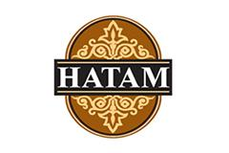

**Captain order**

**2015 - 2017(UAE)**

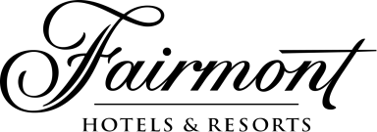

**W AI T E R  
F AI RM O NT HELI O PO LI S AN D TO W ER S  
C AI RO , EG Y PT  
2 0 13 - 2 0 15**

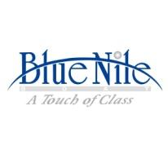

**WAITER**

**Blue Nile land cruise 2012 - 2013**

|  |
| --- |
| *** EDUCATION** |

* **Bachelor Degree of Commerce ( Ain Shams University ) ( Egypt )**
* **Accounting Trainee for 6 Months in AIDO Company**
* **Microsoft Office Course**
* **ICDL Unesco Certificate**
* **Electronic Accounting**
* **Languages**
* **Arabic : ( mother language )**
* **English : (Good)**

WHY CONSIDER MY APPLICATION

Having my accumulated years of experience in this industry and my skill

set, I am confident that I am excellent fit for this job. I am looking for a

long term commitment in my career. I learn fast and do my job well.

Thank you!

Hereby certify that the above information is base on the truth and my knowledge