C.V

Mery Linby Samuel Dous

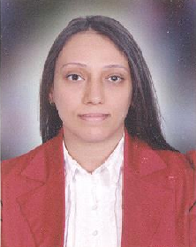
PERSONAL DATA:
- Date of Birth 18th march, 1987
- Place of Birth Assiut .
- Nationality Egyptian .
- Mobile phone 01272624260
- Email merylenby@yahoo.com
- Address Elhakmdar st, Assiut

CAREER OBJECTIVE :
- I am trying to develop my skills and get more experience by joining with a team work .

EDUCATION:
- Bachelor of Arts ( Department of French Language ) from the Faculty of Arts - Assiut University at 2012 .
- Educational Diploma ( Department of French Language ) from the Faculty of Education - Assiut University at 2015 .

QUALIFICATIONS:
- The International Computer Driving License ( ICDL ) .

SKILLS:
- Computer skills ( Microsoft windows 8 , Microsoft office ) .
- Language skills good in English .
- Language skills good in French .
- I can work under pressure for long time , prefer to work in a team , hard worker , ready to learn and have a Good communication .

HOBBIES:
- Reading / Listening to music .
- Traveling .

