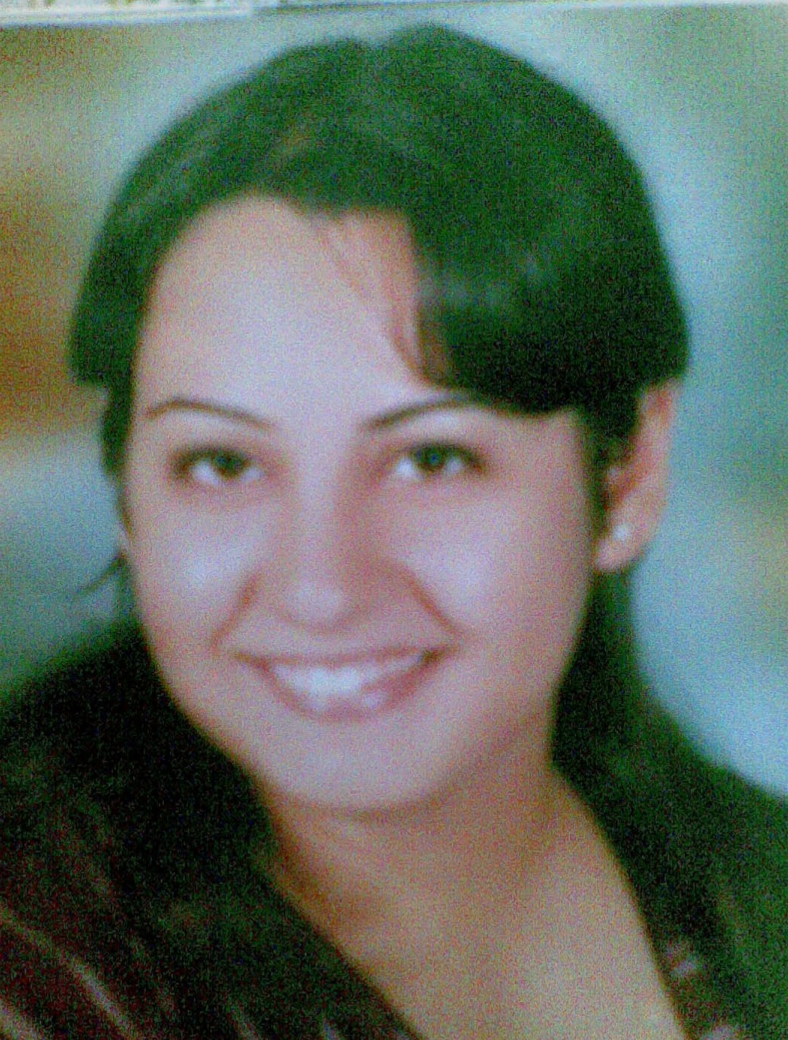
Marvy Shoukry Gerges Hanna

Personal Data:

Name: Marvy Shoukry Girges Hanna

Date of birth: 21-Mar-1990

Address:, . Abd El Naem st, El_Haram,Giza

Cell phone number: 0122-60-41-207

E-mail address: marvy_girgis2011@yahoo.com

Education:

- June 2011: Graduate from Faculty of Tourism and Hotels, Fayoum University.

* Degree: Good.

Courses:

- On Feb 2011: ICDL course
- On Feb 2009: Italian course in El_Don Bosko

Language skills:

Arabic: Mother language.

English: Good Speaking and writing.

Italy: Well Spoken and Reading.

Computer skills:

- Excellent command in the internet skills.

- Very Good command in Microsoft office 2003.
(Word, Excel, PowerPoint, Access)

Personal skills:

Responsible, Serious at work, Cooperative, people oriented, Ambitious, Fast learner, Good in Leading Groups.

Objective:

Seeking for a good interpersonal job position where my skills are needed and improved.

