Ahmed Tawfik Abd Elrahman Mohammed  Minia Elkamh . Sharkia.  Mobile 01221719394 - 01068706402  Engineers Syndicate ID: 191/7705939/2016/2  E-Mail:Ahmedtawfik218@yahoo.com  Date of Birth: 5/6/1993  Marital Status: Married  Military status: final exception | 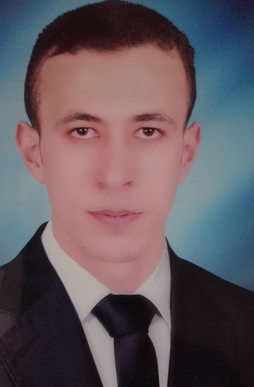

Objective

I am looking forward to upgrade myself, my experience and my life too. And I think I can do that when I work in a bigger company in a different rang. Joining your company will give me that. Hopefully.

Education

B.Sc. In mechanical Power Engineering, Al Salam higher institute for engineering and technology.
Graduation Year: 2016, Grade: Very good
Graduation Project: hydraulic power application (gate works by hydraulic)
Project Grade: Excellent.

Work Experience

- I Worked at jushi Egypt for fiberglass company from 5 /3/2017 to 29/5/2017 as mechanical maintenance engineer.
- I Worked at Helwan diesel engines company from 29/5/2017 to 6/7/2022 as a mechanical maintenance engineer.
- I work at Abu zaabal for special industries company from 7/7/2022 to now as a mechanical maintenance engineer.
Training

Abu Zaabal Co.(AZFC)

- work in turbine and different types of pumps.
- Fundamentals of mechanics for Industrial.
- preventive maintenance

Emic united pharmaceuticals (E U P)

- The fundamentals of Safety.
- preventive maintenance
- HVAC systems.
- caterpillar 3512 engine

Courses

- Production planning and follow-up
- Lean & six sigma (lean green belt)
- Risk management
- 4th industrial revolution (SCADA&MES)

SKILLS

SOFTWARE SKILLS

- MATLAB
- AutoCAD.
- Microsoft Office Applications (Word, Excel, PowerPoint).

TECHNICAL SKILLS:

    - Good knowledge in………. power station.
    - Good knowledge in………. . diesel and petrol engine.
    - Good knowledge in ………. hydraulic and pneumatic circuits.
    - Good knowledge in…………HVAC system.
    - Good knowledge in ………… for how to use different types of tools

PERSONAL SKILLS

- valid driver's license
- Ambitious and Keen to learn & eager to gain more qualifications.
- Hard worker and have the ability to work under pressure.
- A good Team Player and interested in the success of my company.
- Selling Skills and have experience in the market.

LANGUAGE SKILLS

  - Arabic Native Language
  - English Good spoken and written

