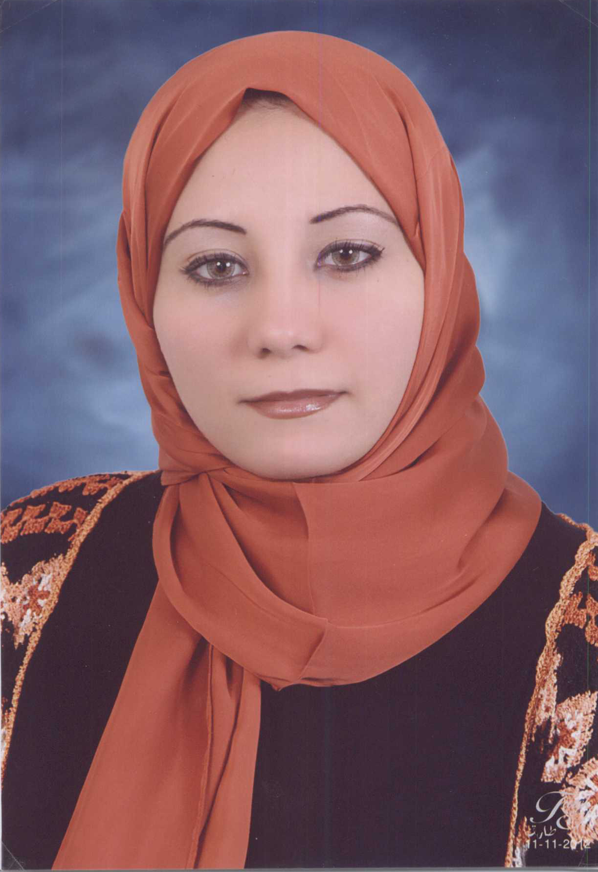

Reham Mohamed Safaa El-Din
Address: 60 Nozha st, Ghamra. , Cairo

Telephone: (202)24828500

Mobile: (20) 010– 22801602

E-mail: rehamroga@yahoo.com
Date of Birth: 20th April 1987

Nationality: Egyptian

OBJECTIVE
A challenging career opportunity in the field of Management Sciences where my Soft Skills, Education Background and Managerial Skills would be employed and could help in the business growth successfully.

EDUCATION

Bachelor degree of Management Sciences (2008)
Future Academy, Cairo, Egypt.
GPA: V. Good.

Experience
2010-2012 Roaaya Design ( Secretary )
- Identifying and scheduling interviews Dean based on the reporting instructions and directions.
to respond to telephone calls and convert them to the Dean on the basis of guidance daily amount.
- Receive incoming transactions internally.
- Follow-up transactions at the departments and sections outside the college.
- Supervise and fax units.
- Remember transactions and decisions to refer to when needed.
- Perform any other functions related to the field of jurisdiction.

2013-2014 EL Khalig Elnassery (Accountant)
- Preparing Th Tax Invoice
- Recording in the sheet of accountant
- Data Entry
- Riving the Bills
- Recording The Revenue and the expenses
2015-2016 Faculty of Agriculture – Ain Shams University (Cultural Relations)
- Data Entry

Computer skills
- Excellent command of Microsoft Office Applications
(Word, Excel, PowerPoint, Access).
- Good Knowledge of Surfing Internet.
- Knowledge of Microsoft outlook configuration and troubleshooting
Language:
- Arabic (Mother tongue).
- Good command of English; spoken and written.

Personal skills:
- Strong analytical and problem solving skills.
- Excellent time management and organization skills.
- Good leadership skills.
- Ability to work independently with very good interpersonal skills.
- Excellent team work skills.
- Keen to learn new skills and upgrade existing skills
- Able to work under continuous pressure & well independently.

Secretarial Diploma:
- Windows xp & Windows 7
- MS word 2007 , MS excel 2007 for secretary , MS power point 2007 , MS outlook 2007 ,MS access2007 ,MS publisher 2007 , MS infopath2007
- Typing speed, filling skills, cv and interview skills , presentation skills

Extracurricular activities
- Member in resala"Nasr city".
- Member at maan team for human development.

INTERESTS

Reading, net browsing and traveling.

REFRENCES AVAILABLE UPON REQUEST

