

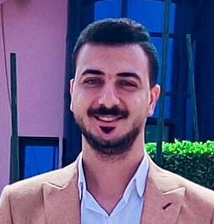

A N D R E W

R A A F A T

## CONTACT

■ andrewrafat707@gmail.com

■ 01280141772

■ Giza & Sohage

## EXPERIENCE

03. 2023 - 05.2023  Customer Service

xceed, Cairo,  Maadi

09.2023 – Current Sales Account manager

MISR life Insurance, Cairo



## SKILLS

* Live chat operating
* Phone system adept
* Helpful and proactive
* Adobe Premiere CC expertise
* Logo creation (<https://www.behance.net/andrewrafat>)
* Adobe Creative Suite (Photoshop, Illustrator, InDesign, Premier, After effect )
* Creative copy writing
* Copy writing and editing
* Microsoft Office expertise
* محرر صحفي لدي البيان
* محرر صحفي لدي الديار
* نائب رئيس قسم الحوادث في الديار
* رئيس تحرير بقناة الشمس برنامج (ماستر)
* Sales account manager in (MISR Life insurance)
* Ability to work within a team work under pressure Building social relationships Solve problems while working

## EDUCATION

2021 MTI University, Cairo, C

Certificate of Higher Education: mass communication

## COURCES

2020 dahab academy, Cairo, C

TV broadcast

2023 Arcplan Group, Giza

Graphic design

## LANGUAGES

## 

**Arab**: Mother language

English: B1

Intermediate