*Ahmed Samir Ahmed Shalaby*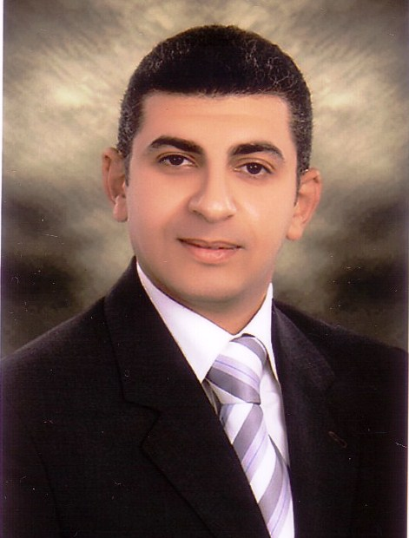

*14 fouad Mohammed ewais st, Mustafa kamel*

***Alexandria,***

***Egypt***

***Phone:- (Home) :-035425704***

***(Cell phone):- 01005673017***

***Email: - ahmed.samir.shalaby1 @ gmail.com***

*PERSONAL INFORMATION*

*. Date of BIRTH: - DEC 20- 1979*

*.Nationality:- Egyptian*

*.Marital status: - married*

*.military service: - done*

*Education:-*

*Bachelor's degree of law (2004)*

*General grade: - acceptable.*

*Work Experience*

*6/2004 1/2005*

*Elementary lawyer in (Mr. hazem osman ) office*

*Who is cassation lawyer at supreme administrative courts*

*1/2005 3/2006*

*Military service*

*4/2006 - 12/2009*

*) Seales representative at shoukry for trading {TOYOTA & Hyundai*

***1/2010 till now***

***EL TAREK AUTOMOTIVE***

**( AUDI . VOLKSWAGEN ,JEEP. DODGE. CHRYSLER. FORD. SEAT. ALFA ROMEO, BRILLIANCE, FIAT, KIA,**

**RENAULT, NISSAN, SUZUKI, MAZDA, HYUNDAI, GELLY, CHERY, CHANGAN, CHEVROLET, OPEL, MITSUBISHI,**

**) Peugeot,**

**1/12010 -1/1/2013 seales representative at El Tarek automotive automotive**

**2/1/2013 1/1/2014 senior seales at El Tarek automotive**

**1/1/2014- till now team leader and Audi brand manger at el tarek**

**1/12019 - show room manger (peugeot branch) at El Tarek automotive**

*Languages :-*

*Arabic: - as mother tongue*

*English: - fluent (graduate from victory college school)*

*Skills*

*\**working under pressure , mastering the art and skills of selling and motivating the team to achieve the highest results. Work to solve the problems of customers.

Training new sellers and giving them the art of selling and how to deal with customers. Focus on setting time plans to achieve success and achieve the highest sales.

*Have the pleasure to submit my c.v that I hope to meet your requirements*

*For new challenging job between the members of your staff*