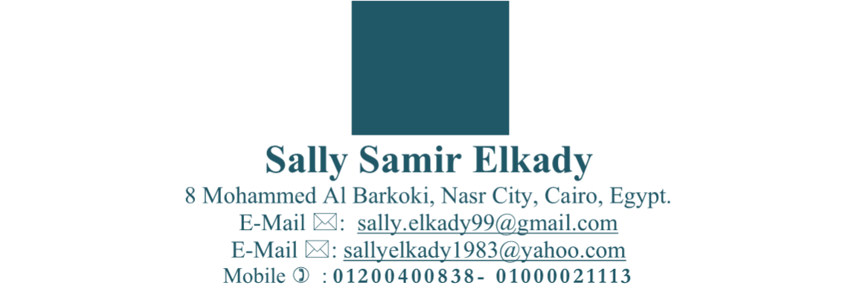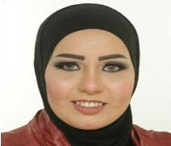

**Sally Samir Elkady**

8

Mohammed Al B

arkoki, Nasr City, Cairo, Egypt.

E

-

Mail



:

sally.elkady99@gmail.com

E

-

Mail



:

sallyelkady1983@yahoo.com

Mobile



:

**01200400838**

**-**

**01000021113**

**Curriculum Vitae**

# Objective:-

Seeking a challenging position where I can use my skills to take advantage of my education, and gain experience in the field of accounting and the stock market and any other area will add to my character new experiences and skills.

# Personal Details:-

* **Name**: Sally Samir Elkady.
* **Address**: 8 Mohammed Al-Barkoki street, Nasr City, Cairo, Egypt.
* **Date of Birth**: 18/12/1983.
* **Place of Birth**: Saudi Arabia.
* **Marital Status**: Married.
* **Nationality**: Egyptian.
* **Religion**: Muslim.

# Education:-

▪ Graduated from faculty of commerce 2006, Accounting department, Ain Shams University, Cairo,Egypt.

# Skills:-

## Computer Skills:-

* Excellent knowledge of M.S. Word and Excel.
* Very Good knowledge of M.S. Powerpoint and Access.

## Language Skills:-

* Native language Arabic.
* Good command of both written and spoken English.

## Other Skills:-

* Motivating and empowering others.
* Organizing events and using time.
* Respecting others, interacting well.
* Working hard for career goals.
* Making decision & taking action.
* Working under stress.
* Capable of working in a teamwork.
* Working through various projects and activities at the same time.
* Good negotiation skills.
* Good communication skills.
* Upgrading my skills all the time.

# Training courses:-

o **February 2007:-** Mirs for Central Clearing, Depository and Registry “MCDR” License.

o **April 2007 - July 2007**:- Basic Business Skills Acquisition (BBSA) Cairo, Egypt, Sponsored by the Future Generation Foundation (FGF) Training.

* Developed Language and Computer skills.
* Enhanced Presentation & project development skills.
* Acquired basic business skills including marketing, sales, banking, accounting, business correspondence, and report writing.

* **February 2008:-** Invest On Shares.

* **15 March 2016:-** Workshop in the field of Voice Over.

* **9 October 2017:-** Online course in Business Etiquette and Professionalism from AmCham Egypt.

* **10 October 2017:-** Online course in Basic Presentation Skills from AmCham Egypt.
* **15 October 2017:-** Online course in E-mail Essentials for Business from AmCham Egypt.

* **16 October 2017:-** Online course in The Voice of Leadership from AmCham Egypt.

* **17 October 2017:-** **:-** Online course in Risk Management from AmCham Egypt.

# Work Experience:-

* **July 2004:-** Summer training in Arab African International Bank “AAIB” Cairo, Egypt.
  + Accountant.
  + Warranty.
  + Balance Sheet**.**
* **January 2007:-** Blom Bank, Cairo, Egypt.

o **July 2007:-** Blom Securities company, Cairo, Egypt.

o **From December 2007 till July 2016:-** Sigma Capital Holding company, Cairo, Egypt**.**

* + **Custodian Department:-** 
    - Deposit Acts: - convert it from physical format to be available on the (MCDR) in his account.
    - Placing:- Transfer the balance of shares from old code to the new one for the same client.
    - Portfolio Transfer:- Sending & Receiving the portfolio to & from the other custodian.
    - Freezing Of Shares:- As per clients’ orders (may be for attending general assembly or for getting loan,…etc).
    - Correcting:- According to executive mistake.
    - Collecting Coupon:- As per the clients’ orders.
    - Collecting Commission:- From the brokerage companies.

* **From May 2015 till Abril 2017:-** Working as a freelance translator from English to Arabic in Arab British Academy for Higher Education (www.abahe.co.uk).
* **From June 2017 till January 2022:-** Working as a freelance translator from English to Arabic in Transn company (www.transn.com).
* **From April 2019 till December 2021:-** Working as a freelance translator from English to Arabic in Whiteglobe Company.
* **From April 2019 till December 2021:-** Working as a freelance voice-over artist in Arabic language in Whiteglobe Company.
* **From January 2020 till July 2020:-** Working as a team leader in Libano-Suisse Takaful Egypt company.
* **From November 2020 till now Working in Arabeya Online for Securities Brokerage Company, A Subsidiary of NI Capital Holding: -** Working on listing and registration of joint stock companies to be listed in MCDR system, working on OTC operations and working on all operations related to custodian services and settlements with MCDR company.