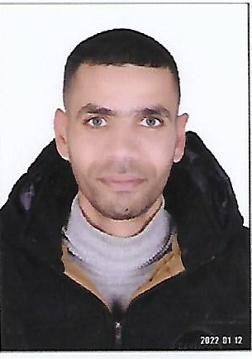
cv
Personal Data :
Name: - Mohamed Mahmoud Mohamed Morsi
Nationality : Egyptian
Religion : Muslim
The national number:- 28710011903315
Date of birth: 1/10/1987
Phone: 01027023718
Address: Ismailia - Fayed - 19 Residential Complex Street - Economic Residences
Marital status: Married
Attitude towards conscription: The military service has been completed

Educational Qualification:-
Qualification: - Technical commercial diploma
Graduation year: 2004
Academic and practical experience

Construction Company.

- Working as a storekeeper in Rogina Tourist Village - Nuweiba.
- Working as an administrative security supervisor at Orascom
- Working as an operation technician in addition to a shipping technician at the Arabian Energy Company for Natural Gas.
- Holds a GTSC fires course from Maadi - Cairo.
- Forklift driver

personal abilities
• Ability to work under pressure
• The ability to adapt to the work team
• Flexibility in dealing with others
• The ability to analyze problems and find solutions to them
• The ability to innovate and add to what is in the interest of work
• Commitment to the rules and working hours

