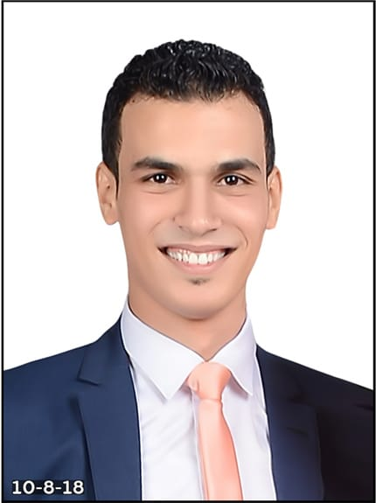
Alaa Ahmed Mohamed Shenishen
Bachelor of Sharia and Law 2018
Tel: 01022997611
E-mail: alaaahmed6395@gmail.com
Address: Qotor, Gharbiya, Egypt.
Academic Qualifications
- B.SC Degree of Sharia and Law
- Master's degree in public law
Technical Skills
- ICDL Certificate Awarded by AUC.
- Language Certificate Awarded By AUC.
- Internet ability.
Personal Qualities
- Positive attitude toward work and great ability towards results oriented output.
- Excellent communication / inter personal skills to interact individuals at all levels.
- Adapt new concepts quickly while working under pressure.
Languages
- Arabic “Mother Tongue”
- English “Very good”
Work Experiences
- Financial & Administrative manager of Alkadi Company.
- Financial & Administrative manager of Aldawlia Company.
- Financial & Administrative manager of ID SCAN X-ray Center.
Personal Information
D. O. B.: March 6, 1995
Nationality: Egyptian
Marital Status: Married
Military Status: Exempt
Driving License: Valid

