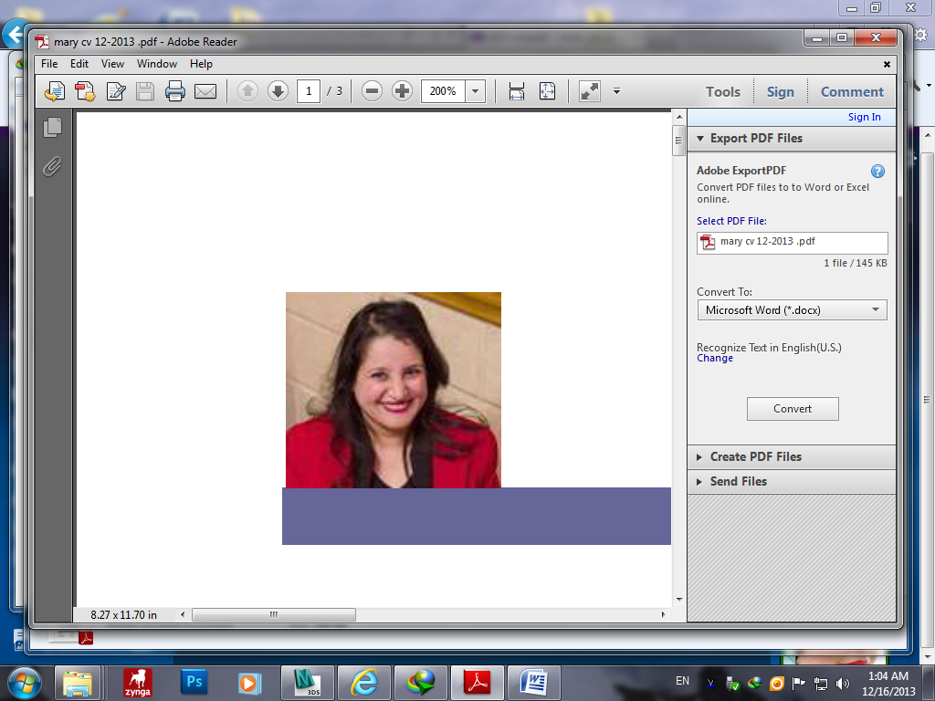

# PERSONAL INFORMATION

**Name :**Mary Soliman FayekMegally**.**

**Mobile No. :. 01111737026/ 01220609134**/ 203-5925945

**Adress**:El-Ibrahemia ,Alexandria, Egypt

**Nationality:**Egyptian

**Place of Birth:** Alexandria/Egypt

**BirthDate:**3/4/1977

**Driver’s License:**Valid

**Marital Status:** Married

**Occupation:**Administration

**Email**:[Programmer.mary@gmail.com](mailto:Programmer.mary@gmail.com)

**Samples:**<https://www.linkedin.com/in/mary-soliman-52b399132/>

https://www.freelancer.com/u/MaryFayek

https://www.youtube.com/channel/UCuTFKBXpEcy0z0VftbC0GFg?view_as=subscriber

# EDUCATIONAL INFORMATION

**School:**Nabawia Musa Eltagribia.

**Faculty:** Commerce Alexandria University,

Business Administration department, graduated at 2001

# CERTIFICATE ACHIEVED

* Program Planning certificate 2004(excellent).
* Microsoft Office certificate 2004(excellent).
* Graphic & Web Design certificate 2011.
* Search Engine Optimization 2011.
* Certified Computer Maintenance A+ 2012.
* Autodesk Revit Architecture2019(cad master).
* Autodesk 3dsmax 2019 professional (cad master).
* Information Technology skillful The Ministry of Manpower.

# LANGUAGE SKILLS

Good Command of written & Spoken English

Native Language: Arabic.

# COMPUTER SKILLS

* Microsoft office (Word- Excel-PowerPoint- Access 97-2016)
* Visual basic 6
* Sql
* Adobe Photoshop cs5
* Flash
* Gold Show-movie maker
* Dreamweaver
* JavaScript Html
* Ajax Dreamweaver
* Search Engine Optimization
* Css
* Pc trouble shouting programs
* Windows Xp-7-8-10
* Internet Explorer
* A+ programmes
* Format factory
* Outlook and merge fields
* Autocad 2007
* Revit 2019
* 3dsmax 2020

# JOB EXPERIENCE

**Private work:**

* Interior designer 3dmax :
  + Modeling, v-ray and rendering (July-2020).
* PC –Programmer (analysis , database, hr, accounting, design, develop from A to Z):
  + Hospital program (2015).
  + Pediatrician (children dr)program (September-2011).
  + School program (April-2012).
  + Library program (May-2013).
  + Clinic program (April-2013).
* AutoCAD architecture assistant (2015-2020):
  + Architectural Drawings.
  + Electrolytic and sanitary drawings for apartments.
  + Quantity calculations with polylines and excel.
* Banner design, Decor plays (2016).
* Teaching Music, Computer and Math.

**Little Flock House nursery school (11/2010-5/2014):**

* Develop program. until now
* Montage (2014).
* Banner design (2014).
* Pc trouble shouting (software)
* Playing music (August-2013).
* Power point presentations (2011-2014).
* Programmer:
* Program for the absence and vacations (January -2012).
* Program for attending and leaving gives reports about daily absence, permissions, delay and other systems (May -2012).
* Printing Certificates of appreciation program (August -2013).
* Library program (May -2013).
* Program for receipts, reports accounting (February-2011).
* Program for booking nursery children (October-2011).
* Program for organize cds (October-2011).
* Program for booking concerts’ Photos (November-2011).

**Snow White Company** (April -2010, November-2010):

* Secretary(Answer phones record data of customers , recognize import and export letters, follow maintenance and Tender offer) .
* Marketing with net.
* Pc Programmer:
* Agenda program (July-2010).
* Program for import, export and publishing data (August-2010).
* Program for following up maintenance (October-2010).

**Recovery Center "Bon Pasteur"** (September-2005/September-2009)**:**

* Management of entertainment.
* Treatment by work.
* Purchases & Stores.
* Editing food program.

**Commercial School**(September -2004/ February-2005)**:**

* Teaching commercial subjects.

# EXTRA SKILLS

Publishing data from data base,sending some e-mails at once, graphic design, Playing music , drawing pictures, teaching, playing ping pong, swimming, riding a bicycle, needle hand craft, art of cutting wood preparing competition programs, PowerPoint animated with music , Cooking for 40 person in journey and effective leader course.

Hope that satisfies your requirements

Mary Soliman

* Interior designer 3dmax :
* 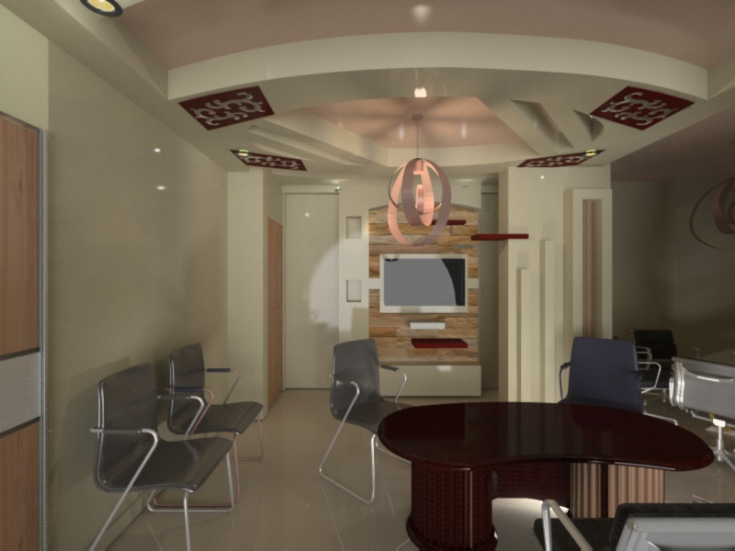
* Banner design, photshop.

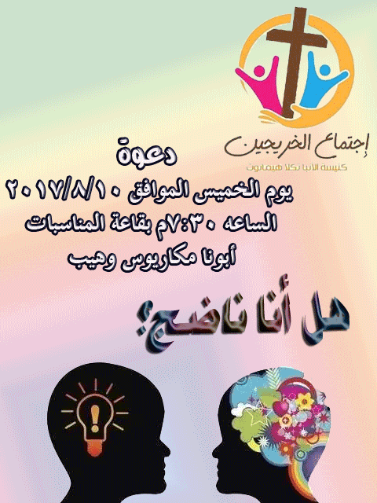

* PC –Programmer (analysis , database, accounting, design, develop from A to Z):
  + 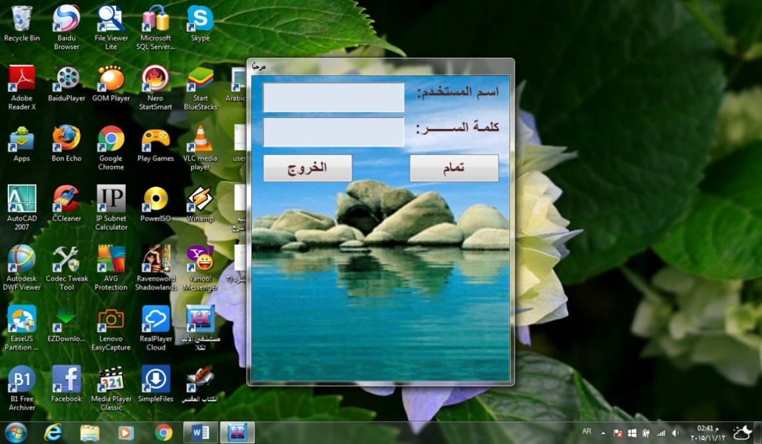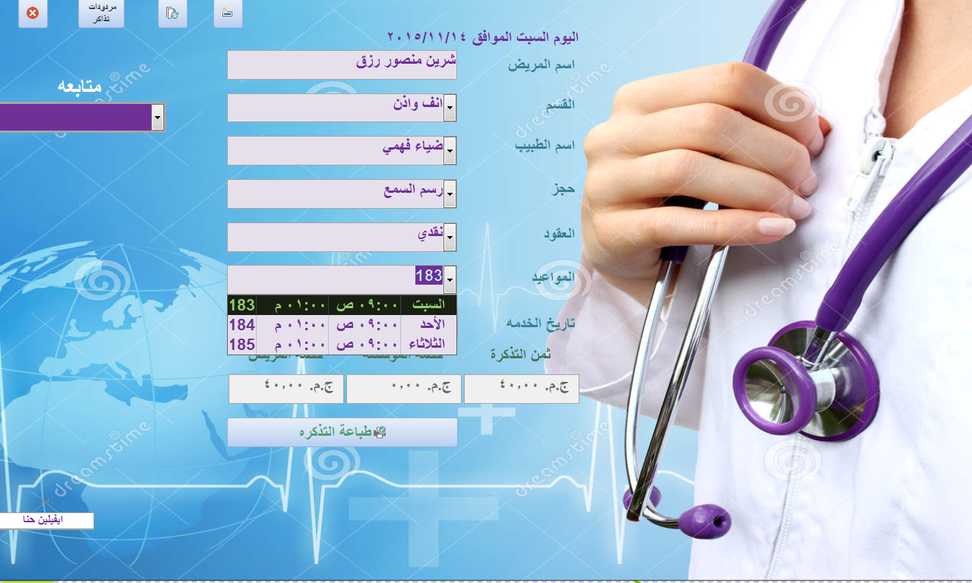

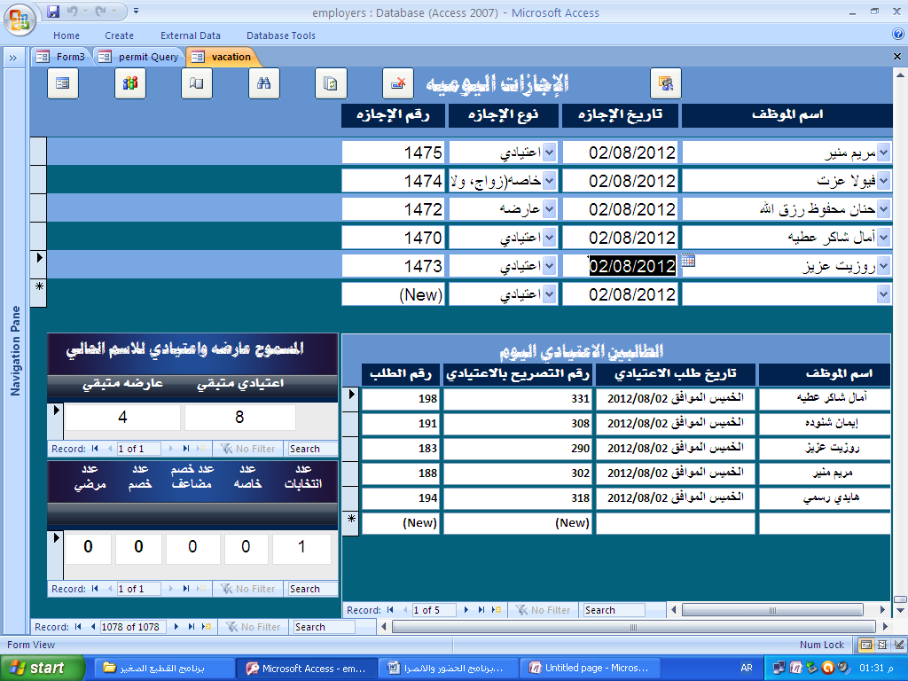

* AutoCAD architecture assistant (2015-2020):

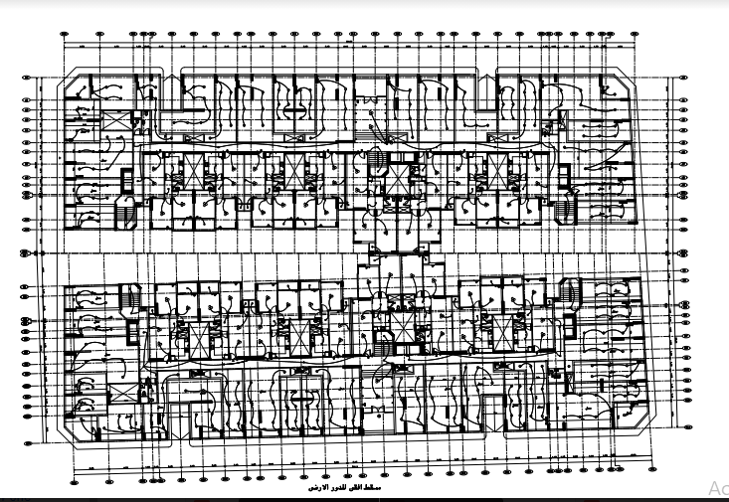

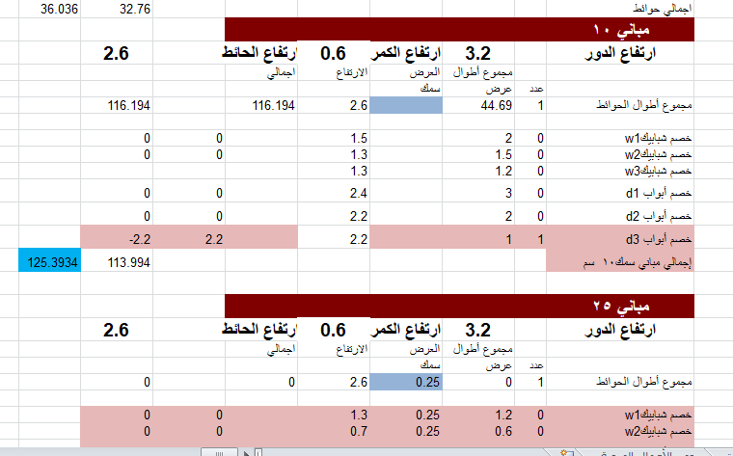

* Montage:
  + https://www.youtube.com/watch?v=h8IYuR52w5o&t=17s
* Playing Music:
  + https://www.youtube.com/watch?v=q1Rsrn7GMGU
* Power point presentations (2011-2014).
  + <https://www.4shared.com/file/MNd7XnPO/Petite_maman_chrie.html>
  + https://www.4shared.com/folder/mb86CNXG/kids_songs_powerpoint.html