***Curriculum Vitae***

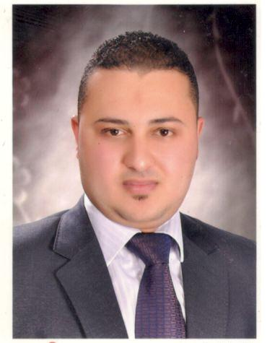

**Name: *Mohamed Magdy Maged***

**Nationality: *Egyptian*.**

**Military status: Final dismissal**

**Nationality: *Egyptian***

**Date of Birth: *25/2/1986***

Contact Data:

**Address: Mostafa Kamel St .Behand Seklam company**

**City: Alexandria**

**Country: Egypt**

**Mobile: +2 01033035541 - 01204096103**

**E-Mail: heroman10100@yahoo.com**

Educational Background:

* **Bachelor of Law 2009**
* **Alexandria university**

Personal experience:

* Lawyer 4 years from 2009 to 2012
* Accountant at kingdom of Saudi (6 years )

Personal Qualifications:

* **Creative, self-motivated, reliable and dynamic.**
* **Good communication skills.**
* **Good presentation skills.**
* **Enthusiastic, active, hard worker and presentable.**
* **Good at working under pressure and meeting deadlines.**
* **Ability to work individually as a co-operative team member.**
* **Ability to learn new tasks quickly.**
* **Needing little or no supervising.**
* **Able to adopt different circumstances.**
* **Good analytic and problem solving skills.**

Language Skills:

English: **Good command of spoken and written English.**

Interests:

* **Reading and watching news.**
* **Surfing the internet.**
* **Travelling and swimming.**

­