**Mohamed Ahmed Mahmud Khalifa**

**Location:**  Giza **Date of Birth:** 1/4/1992

**Telephone:** 01110047898 **Military Status:** Exemption

**Email:** Mokhalifa043@gmail.com

**LINKED IN** <https://www.linkedin.com/in/mo-khalifa-420333177/>

Career summary

I'm seeking to join a reputable corporation where I can build my career and add value helping it to achieve its strategic vision and mission, utilizing my communication, problem-solving and business research skills. Areas of expertise include Communications, Negotiation and Hard working.

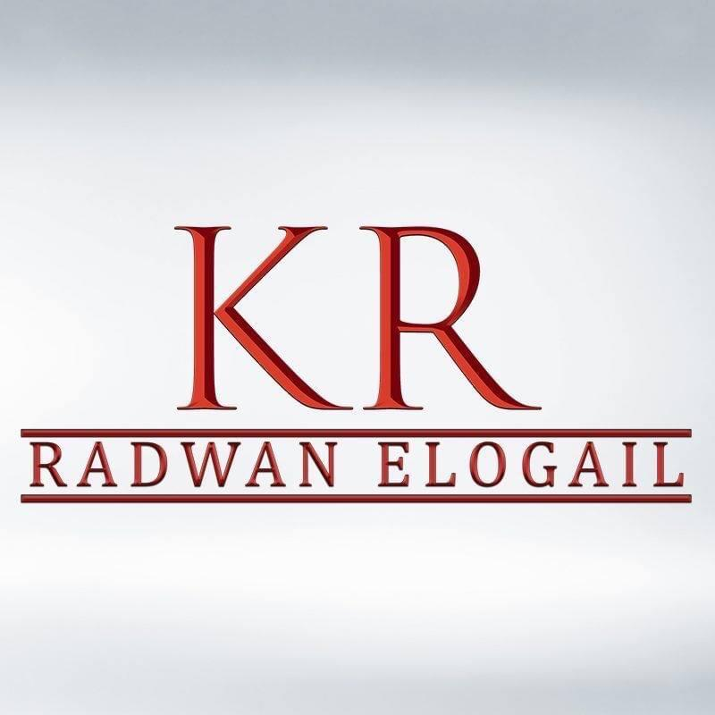

**2020 – present.** **ICDP (Dina Farms)**  **HR Generalist.**

**Key responsibilities**

**• Tracking leaves and absences through attendance system**

**• Informing employees to submit a (scanned) signed and approved relevant paper from his responsible.**

**• Update leave balance on CRM.**

**• Approve annual, sick and casual leaves requests.**

**• Approve over time requests after validation from relevant supervisor/head.**

**• Follow up on fingerprint attendance and take relevant actions.**

**• Provide needed support to employees covering topics such as private medical insurance, leave balances and resolving any problems that may arise.**

**• Keep employee’s files and records in soft and hard copy to include on code zone system and employees’ file.**

**• Ensure compliance with labor regulations.**

**• Send warnings letters, labor law registration forms.**

**• Owner of all recruitment process:(Job Posting. Select potential candidacies.Organizeinterview with relevant supervisor Send the job offer to the accepted candidates. Gather all necessary hiring documents**

**• Secure complete employees' files (required documents, contracts, leave requests, declarations... etc.).**

**• Ensure proper update of all employees’ contracts (renewal and termination), and inform the relevant managers with the contracts that need renewal (two-month prior of the expiration date).**

**• Submit a monthly report to the account manager with new hires, and resignations.**

**• Enter all employee data into the Code Zone, and approve all pending requests.**

**• Prepare forms 1, 2 and 6 and ensure that they are in accordance with the Social Insurance Law and updated on the company's rules of procedures.**

**• Update employee’s database to ensure an accuracy of personal information.**

**• Prepare the necessary documents for government insurance and follow up the receipt of government health insurance cards.**

**• Support in the monthly payroll preparation.**

**• Apply all new tasks requested by the Director of Human Resources.**

**Jan 2020 – present (Part time)** **World of travel**  **(2 Company)** **HR Generalist**

**Key responsibilities (Saudi international company) (Jazeel Digital Marketing - Happy life travel &tourism)**

* **Similar to the responsibilities of previous companies**

**July 2019 - Dec 2019. SADAD exp HR Recruitment Specialist**

**Key responsibilities (Saudi international company) (Neom – mostsharak – khepra ) (3 Company)**

* **Owner of all recruitment process:(Job Posting. Select potential candidacies. Organize interview with relevant supervisor Send the job offer to the accepted candidates. Gather all necessary hiring documents**
* **Ensure proper update of all employees’ contracts (renewal and termination), and inform the relevant managers with the contracts that need renewal (two-month prior of the expiration date).**
* **Conduct personal interviews and prepare for them and follow up with Candidates for the job scheduling training courses**
* **Promote open roles with online job advertisements.**
* **Preparation of job offers and work contracts**
* **Preparation of monthly staff evaluations and reports.**

**Jan 2018 –July 2019 Hagar pharmacies HR Generalist**

**Key responsibilities**

* Conduct personal interviews and prepare for them and follow up with

Candidates for the job scheduling training courses

* Handle social insurance monthly settlement, process and preparing all related

Forms related to his/her account.

* Promote open roles with online job advertisements.
* Preparation of job offers and work contracts
* Calculation of salaries Consider overtime, holidays and evening shifts. Oversee employee attendance and work schedules including rest periods, overtime and duration paid.
* Preparation of monthly staff evaluations and reports.
* Address issues and questions regarding payroll from employees and superiors -Prepare reports for upper management, finance department etc.
* Record employee information, such as sick leaves, transfers, and resignations, in order to maintain and update payroll records
* Ensure that payroll is calculated correctly and transferred correctly to the employee's accounts

**Jan 2016 to Nov 2017 RADWAN ELOGAEL STORES** **HR coordinator**

**Key responsibilities**

* Handle social insurance monthly settlement, process and preparing all related forms related to his/her account.
* Preparation of job offers and work contracts.
* Address issues and questions regarding payroll from employees and superiors.
* -Record employee information, such as sick leaves, transfers, and resignations, in order to maintain and update payroll records.

**Jan 2014 to Dec 2015 Ali Abdul Aziz Abo hesham office****Lawyer (Training)**

Education

* **Bachelor of Law –** Faculty of Law, Cairo University, Sep 2009 to Oct 2013

Bachelor degree in legal Grade very good with agreed of honours 86%

* **Master of the law grade good**. 2017

Training & Courses

* HR Professional Certificate at HCC ( 100 Hours – off line) fep2020 to May 2020
* EDRAAK Certificate for HRM (online course) April 2020.
* DOROOB certificate for HRM (online course) April 2020.
* OMRAN Certificate for HRM (online course) April 2020.
* Successfully completed summer training courses soft skills 2013.
* English Course. 2012.
* ICDL courses. 2010

Language

English ( v good) French ( good)

Skills

* Customer Service.
* Communication Skills.
* Active Learning.
* Problem Solving.
* Sales Skills.
* Computer Skills (MS office, Internet)
* Coordination.
* Flexibility.
* Teamwork.
* Self-Motivated.
* Ability to work under pressure.
* I have Excellent knowledge about (labour law and Insurance law)