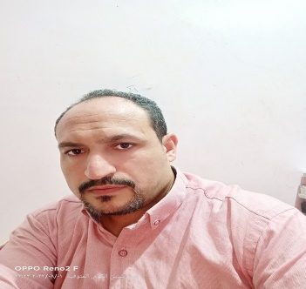**Curriculum Vitae (C.V.)**

**Personal Data:-**

|  |  |
| --- | --- |
| **Name** | **Mohammed El-sayed Hussein El-desoky** |
| **Nationality** | **Egyptian** |
| **Religion** | **Moslem** |
| **Gender** | **Male** |
| **Birth Date** | **11/1/1984** |
| **Marital Status** | **Married** |
| **Adress** | **El Bajour/El Minofiya** |
| **Telephone** | **Mob\01062021583 \01112326894** |
| **Title** | **Chemist** |

**Educational Data:-**

|  |  |
| --- | --- |
| **Educational Degree** | **B.Sc. In Geochemistry from Faculity of Science in Shebin El-Kawm-Minoufiya University.** |
| **Graduation Date** | **May 2006** |
| **B.Sc.Grade** | **Very Good** |
| **Appreciation** | **Good** |
| **High Educational Degree** | **Diploma in Biochemistry analysis,(2017).**  **General diploma in methods of teaching science.(2018)** |
| **Appreciation** | **In both Very Good** |
| **Languadge Skills** | **Arabic(Mother Tongue).English (Very Good)** |
| **Computer Skills** | **Windows -Word -Excel -Access** |

**Field Traning:-**

|  |  |
| --- | --- |
| **Training in** | **The Company of Alexandria for Refractories.& University Hospital in Shebin El –Kawm.** |
| **Training Grade** | **Excellent** |
| **Experience** | **Working in the Arab Comp.of Dying and Finshing Cloth. Until(7\2007). Then….. Working in (Laboratory) of Mardini Print Comp. of Dying, Printing Finshing Cloth. Also Working in the Hall Production in the same Comp. Then working in El-Hoda Factory of Dying,Also working in El-Ethad Company of Dying.** |