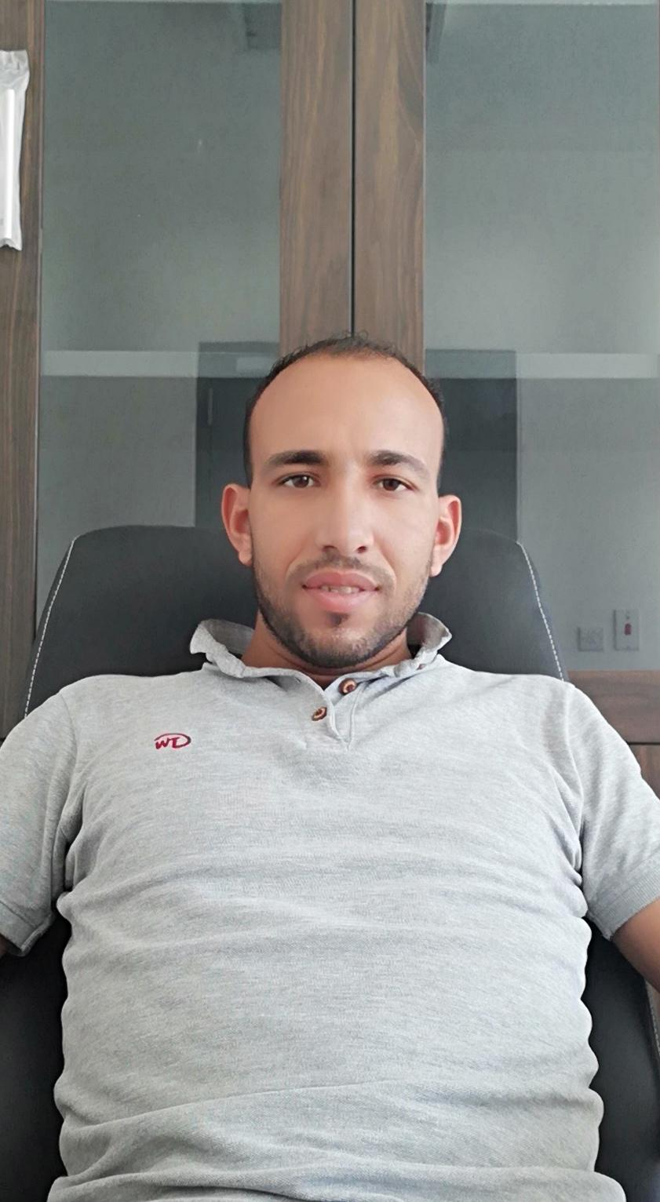

**AHMED ELSAYED**

Mobile No.:+966536825181

Email Address : [ahmed.elbamby012@gmail.com](mailto:ahmed.elbamby012@gmail.com)

**Objective**

Responsible for providing on-site direction and leadership for workers in order to complete jobs within specific guidelines that include quality standards, time requirements, and budget considerations.

**Personal Information**

Name **:**  **Ahmed Elsayed Abdel Aziz Elbamby**

Age **:**  **30 Years Old**

Birthday **:**  **September 01, 1991**

Sex **: Male**

Resident address  **:** **Basioun, Egypt**

Place of birth  **: Gharbia City, Egypt**

Height  **:** **5’4” Ft**

Weight **:** **100 Lbs.**

Status **: Single**

Religion **: Muslim**

Nationality  **: Egyptian**

**Education**

**Course: Electrical Technology**

**School Name:** Tanta University Faculty

**Address:** Tanta City, Egypt

**Year Graduated:** 2008

**Skills**

* **Installation (Power &Lighting System)**
* **Troubleshooting skills ability**
* **Low and high current system**
* **Grounding system**
* **Generator installation.**

**Work Experience**

Company Name **: Al-Kifah Contracting Company (KCC)**

Client  **:** **Tatweer Building Company (TBC)**

Consultant **:** **AECOM**

Position  **: Electrical Foreman**

Duration  **: March 2017 – Present**

**Summary of work**

* Supervised teams for electrical installation and troubleshooting of systems.
* Conducted quality control inspections for conduit and wiring systems.
* Supervised a team of warehouse associates.
* Ensured quality services through active listening and follow through of requests.
* Conducted various maintenance duties upon request.
* Provided exemplary customer service and attention to detail.
* Responsible for the construction of cellular infrastructure for communications industry.
* Responsible for overseeing and providing verbal direction to small crews.
* Close attention to detail and effective problem resolution to ensure customer satisfaction.
* Utilize in depth knowledge of various construction plans, products and supplies to maximize project effectiveness and profitability.

Company Name **: Al-Kifah Contracting Company (KCC)**

Client  **:** **Ministry of Education**

Consultant **:** **Zuhair Fayez**

Position  **: Building Electrician**

Duration  **: January 2014 – February 2017**

**Summary of work**

* Expertise in the installation, repair, testing and maintenance of electrical systems, electrical wiring, equipment, appliances and fixtures.
* Adept at analyzing problems and rapidly finding solutions.
* Strong knowledge of wiring requirements, testing equipment, circuits, meters and industry regulations / codes.
* Diagnose and replace high voltage electrical power lines, pole wiring and underground lines.
* Install circuit breakers, transformers, stabilizers, generators and distribution systems.
* Capable of quickly understanding blueprints, schematics and technical manuals.
* Manage service calls, troubleshoot electrical systems and resolve issues with equipment.
* Coordinate with construction contractors such as HVAC, commercial lighting and other electricians in order to ensure wiring is run to correct locations.

**Character Reference**

**Engr. Mohammad Anees**

QC Electrical Engineer

Al-Kifah Contracting Company

+966-059-340-7486

**Engr. Hossam Abdel Naby**

Senior Electrical Engineer

Al-Kifah Contracting Company

+966-059-362-4175

**Engr. Ahmed Zohier**

Project Manger

Al-Kifah Contracting Company

+966-059-342-5105

I do hereby certify the correctness of the above-mentioned statement.

**Ahmed Elsayed**

Signature