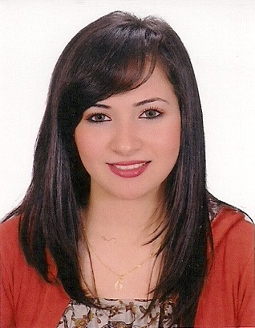

Mariam Talaat Tawfik

**Address**: 17 Mokhles el-alfy, St. , Nasr city, Cairo

**Mob. No. :** 01275222237

**E-Mail**: [Mariamtalaat.t.40@Gmail.com](mailto:Mariamtalaat.t.40@Gmail.com) &

Mariam.Morgan@Wadidegla.com

**✓Personal Data:**

* **Date of birth**: 25/9/1990
* **Nationality**: Egyptian.
* **Marital status**: Married
* **Gender**: Female

**✓Educational Background:**

* **University Degree: faculty of Law**
* **University: Assiut University**
* **Graduation Year: 2011**
* **General Grade: Fair**

**✓Courses:**

* **English General Course in American University.**
* **Customer Service Course at Wadi Degla Holding Company.**
* **Business Writing Skills Course.**
* **Customer service Course.**
* **Communication Skills**
* **Business E-mail**

## ✓Experience:

* **From 2009 till 2010 as a Customer Service in El Khalig El Nassery Co. for Construction.**
* **From 2012 till now as an Admin Assistant Food & Beverage at Wadi Degla Holding Company.**

**✓ Language Skills:**

|  |  |  |  |  |  |  |  |  |  |
| --- | --- | --- | --- | --- | --- | --- | --- | --- | --- |
|  | ***reading*** | | | ***speaking*** | | | ***writing*** | | |
| **Language** | **v. good** | **Good** | **Fair** | **v. good** | **Good** | **Fair** | **v. good** | **Good** | **Fair** |
| **English** |  | **✓** |  |  | **✓** |  |  | **✓** |  |
| **Arabic** | **Mother tongue** | | | | | | | | |

**✓Computer Skills:**

* **Windows**
* **MS. (Word, Excel, Power Point, Outlook).**
* **Internet.**
* **SAP**
* **Micros**
* **Simple touch**

**✓** **Job Requested**:

* **Seeking for a vacancy in a leading company where I can develop my skills.**
* **Highly motivated, energetic and goal oriented.**
* **I have a wide range of communication skills.**
* **Excellent team work spirit.**
* **Able to work under pressure.**
* **Friendly.**