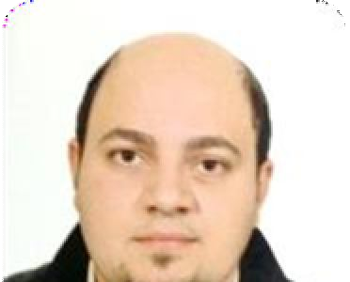

**Romany Mahrous Shenouda**

Romany3000m@gmail.com

Bani Sueif

**I'm seeking a position in Sales filed in which I will add to the company and I will be given a sense of belonging, and where my academic background & experience and skills can be best utilized and developed.**

|  |  |  |
| --- | --- | --- |
| ••• | **Eduction :**  Bachelors Degree of commerce, Cairo university  Faculty of Commerce (Accounting Section), 2006. | |
| ••• | **Personal Data :** |  |
|  | **o Date of Birth :** | 21 Dec 1985 |
|  | **o Nationality :** | Egyptian |
|  | **o Marital Status :** | married |
|  | **o Military Status :**  **Experience :** | exempt |
|  | Experience in different Sales activities with 12 years o f experience, at Egypt.  o Senior medical sales man at Eva pharm farm company.  o Senior medical sales man at Ramco pharm company.  o Senior medical sales man at Sofico pharm company.  o Super Pfizer at sales man at three mas company  ○ Supervisor at amgad pharm company.  ○ All experience in pharmaceutical and cosmetics companies and medical supplies | |

1/2

|  |  |
| --- | --- |
| ••• | **Training & courses :**  **.I. Basic selling skills** o  From merl company . |

# .II. Advanced selling skills

o From counsel company .

**Skills :**

# .III. Languages Skills

* Arabic : Mother tongue
* English : Good

# .IV. Computer Skills

1. M.S Office
2. Windows system
3. Internet reserch

Please treat as confidential 2/2