# LANGUAGES

Arabic -mother language — Native English -Good working experience — Intermediate

# SKILLS

- Good experience in photoshop ,3D MAX ,Auto CAD,V-Ray ,Microsoft Office Programs. - Working with local and international teamate.

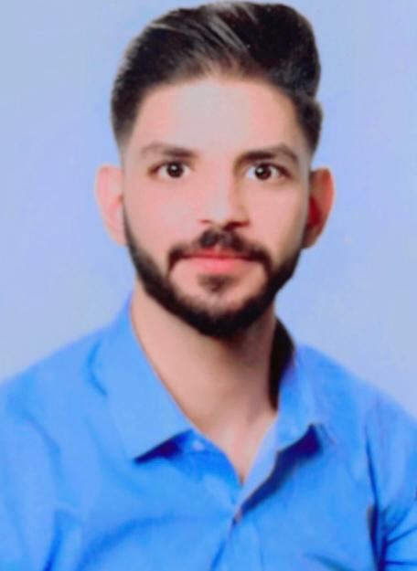

**Iraq-Baghdad**

**1997**

**07810845004**

**Adana.saleh@alrasheedcol.edu.iq**

**ADNAN SALEH KALAHF**

# Highlights

**I am a good worker with the ability to work individually or as a team**

# Experience

**Secretary**

**Alrasheed university college | Baghdad**

**Information Technology division Dec 2018 - feb 2021**

**Public Relations Feb 2016 — Oct 2021**

**B.G business glory | Baghdad**

# Education

**Computer sceinse Oct 2015 — Jun 2019**

**Al-Mansour University College | Baghdad**

# Certifications

* 3D MAX
* Auto CAD
* Photoshop
* V-Ray
* Cisco,A,P
* IT
* LUMION
* Microsoft Office