**Fatima Zahrae Maghnaoui**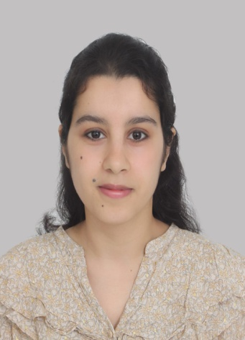

Date of Birth: 1995-09-07

Address: Hay Salam, Morocco

Phone #: 0694167324

Email: fzmaghnaoui@gmail.com

* **Training and Diplomas:**

**2013 - 2015**: Alumna of Access Micro Scholarship Program - AMIDEAST..

**2018-2019**: Hair Stylist Diploma

**2019:** High School degree, Mention good.

**2020- Present: 3nd year university student**- Majoring English studies.

* **Professional Expériences:**

**2016-2018:** **Language Partner with American students from NSLIY and YES Abroad Programs - Amideast**

**-** providing students with dynamic interactive practice of Arabic language, and provide students with the opportunity to use and to further develop the language skills**.**

**2018 - 2019:** **receptionist/notaire**

- Phone call management, and organization of appointments or formatting of documents to establish the files for the production of documents and to gather information for their writing.

**2017: Call Center/ Cleaning service.**

**2017-2018:** **Sales Representative/ sport shoes**

**June 2019:** **Volunteer in the Moroccan African Games**.

- guide athletes around, and greet dignitaries and translate.

Greeting and assistance the participants -.making the badges.

**May-Jun 2020:** **Private translator for a British tourist**

**June-July 2020:** Participant in MPC Youth Forum on Youth Political Participation & Development - Al Akhawayn University in Ifrane.

**June 2022: language guide**

**-** accompanying and guiding a group of American students to their volunteer activity by supporting them with the language

* **Skills and Knowledge’s**
* Proficient with Microsoft Word, Excel and Power Point
* Serious and Reliable
* Driving License Type B
* Attention to Details
* Highly Organized and efficient
* **Langues :**
* Arabic: Native Language
* English: Advanced
* French: Intermediate