PERSONAL INFORMATION | Omar Mustafa Ahmed
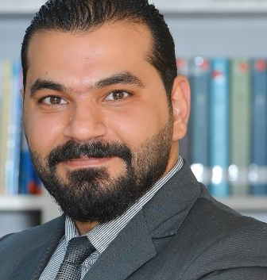 |   Iraq-Kurdistan Region- Erbil
 |  +009647511422951

Samaray_o@yahoo.com
 | Sex Male | Date of birth 3/June/1988 | Nationality /Iraqi

Professional Curriculum Vitae

WORK EXPERIENCE

From 2008 till now 2021 | Private Tutor in the following educational institutions in Jordan-Irbid  -Al-Kawarizmi Educational Institution  -Hilal Educational Institution  -Murshidon Institution  Work as Assistant Manager of HR in Global Insurance Brokers Company-Saudi Arabia .  Work as Manager of Data entrance in I Tag HP Company -Jordan  Work as Manager of Conference System in Safe Travel Plaza -Kurdistan Region- Iraq- Erbil  Work as Purchasing Manager in Ezone Company -Kurdistan Region-Iraq-Erbil  Work as HR Manager in AL-Madeed Company - Kurdistan Region-Iraq -Erbil  Work as Public Relations Manager(Co-Founder) in Liked Squares Company -Kurdistan Region -Iraq-Erbil  Finally Assistant Lecturer in Cihan University-Erbil Full-Time 2013-2017  Salah Aldin University Part-Time 2019-2021  Bayan university Part-Time 2019-2021

EDUCATION AND TRAINING
(2007)  (2009)  (2013)  (2020) | Diploma in IT -University of Cambridge UK  Bachelor in English Language and Literature-Jadara University Jordan
Master’s Degree in English Language and Literature-Jadara University
Jordan
PhD of English Language and Literature- UKM University Malaysia

PERSONAL SKILLS

Mother tongue(s) | Arabic And Kurdish
Other language(s) English | UNDERSTANDING |  | SPEAKING |  | WRITING
 | Listening | Reading | Spoken interaction | Spoken production
 | Prefect | Perfect | Perfect | Perfect | Perfect

Communication skills | - Perfect

Organisational / managerial skills | - Perfect

Job-related skills | - Non

Digital skills | SELF-ASSESSMENT
 | Information processing | Communication | Content creation | Safety | Problem solving
 | Good | Perfect | Very good | Perfect | Very good

Other skills | - Non

Driving licence | Professional Level- Form the Hashemite Kingdom of Jordan

