BIOGRAPHY
PERSONAL DATA 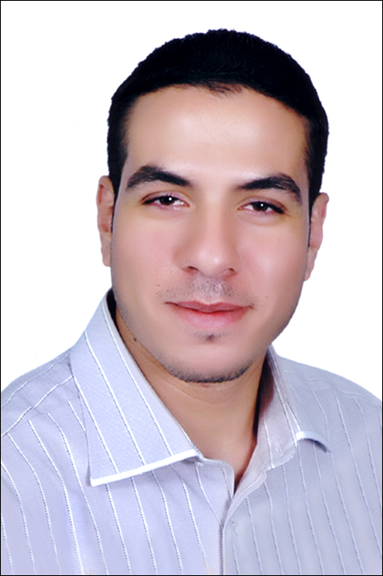
NAME: MAHMOUD ROSHDY KAMAL MOHAMED HAMOUDA
DATE OF BIRTH: 25\01\1985
EGYPT-CAIRO-NASR CITY-EMTDAD RAMSES ADDRESS:
NATIONALITY: EGYPTIAN
RELIGION: MUSLIM
GENDER: MALE
MARITAL STATUS: Married
MILITARY STATUS: Exempt Service
HOME TEL- NUMBER: +2 02 23423172
MOBILE TEL-NUMBER: +2 01095353453 ~ +2 01009907959
E-MAIL ADDRESS: POPOSSSSSSSSSSSSSSSSSSSS@Yahoo.COM
LANGUAGE: ARABIC (MOTHER TONGUE) ENGLISH

EDUCATION
2007: BACHELORUS (INFORMATION SYSTEMS)
2011: General Administration of Civil Protection
ADDITIONAL EDUCATION
2003: OPRETING SYSTEMS.
2003: VISUAL BASIC.
2003: office.
2003: MS-WORD ²⁰⁰⁰.
2005: HTML.
2005: DREAM WAVER.
2007: ENGLISH LANGUAGE.
2011: ICDL ^{Syllabus Version 4.0}.
2010: IT essentials: pc Hardware and software^{+ "report"}.
2010: IT essentials: pc Hardware and software Advanced^{+ "report"}.
2012: Essential C++.

