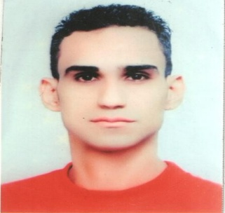

**Mohamed Attia Abed**

**Address :** 77 residences and industrial

housing Wooltex, Shubra Al-

Kheima, Cairo – Egypt

**Tel :** 02 44721369

**Mobile**  **:** 01119141680

**Email :** Mohamedatya954@

Yahoo.com

**Personal Information:-**

**Nationality :** Egyptian

**Date of Birth :** 17/11/1985

**Place of Birth :** Cairo

**Gender :** Male

**Marital Status :** Single

**Places of Residence :** Egypt

**Religion :** Muslim

**Military service :** Edith service appreciated a good example

**­­­­­­­­­­­­­­­­­­­­­­­­­**

**Education:-**

**University degree :** holds a Bcayorius

administrative information

systems (Department of

Computer Science)

**Faculty :** New Cairo Academy of Arts and Sciences

**Graduation Project :** School network information system

**Degree project :** Very Good

**Graduation year**   **:** 2007

**General appreciation :** Good

**Language:-**

**Arabic :** Native Language

**English :** Acceptable

**Training Courses:-**

- Microsoft Office

- He holds a degree from the French organization Blanc (Marketing - Alskartrah

- Computer - foreign language - Management) sponsored by the Ministry of

Youth and Sports and the Association of Fustat .

* Holds a Cisco Certified Network Associate Course (CCNA).

**Computer Skills:-**

* Very good user of Windows, Word, PowerPoint, Excel

* Good surfing skills on the Internet

**Work Experience: -**

**-** Work at LBM Engineering and Computer as engineer

computer and information at Hard Ware system .

**-** Work in the armed forces at branch information

systems and IT service when Hard Ware .

- Work in Etisalat Misr

**Finally:-**

**-** I would like to join you and it is a great honor for me and I

will be your good opinion