**curriculum Vitae**

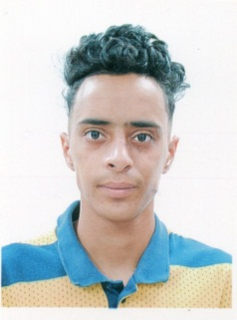

**Mohamed GUELLIL**

**Contact Information**

**Address : ABDELMALEK RAMDHANE– KSAR CHELLALA –**

**Cell Phone : (+213)778.91.41.24**

**Personal Information**

**Date of Birth : 21/01/2002**

**Place of Birth : Ksar Chellala , Tiaret . Algeria**

**Citizenship : Algerian**

**Gender : Male**

**Marital Status : Bachelor**

**Gmail :guelilmohamed4@gmail.com**

**Education**

**Secondary School : 3rd year of secondary education.**

**Diploma : Cleanliness, security and environment.**

**Professional experiences**

**Professional experience of one (01) years in Cleanliness, security and environment**

**in KSAR CHELLALA.**

**Languages**

**Arabic : Excellent**

**English : Middle**

**French : Good**

**Other and personal interests**

* **All obligations are exempt**
* **Good physical and moral condition**
* **Open mind and good sense of responsibility**
* **Serious and friendly**
* **Travelling , Music and sports**