**Curriculum Vitae: Suhad Al-Smadi**

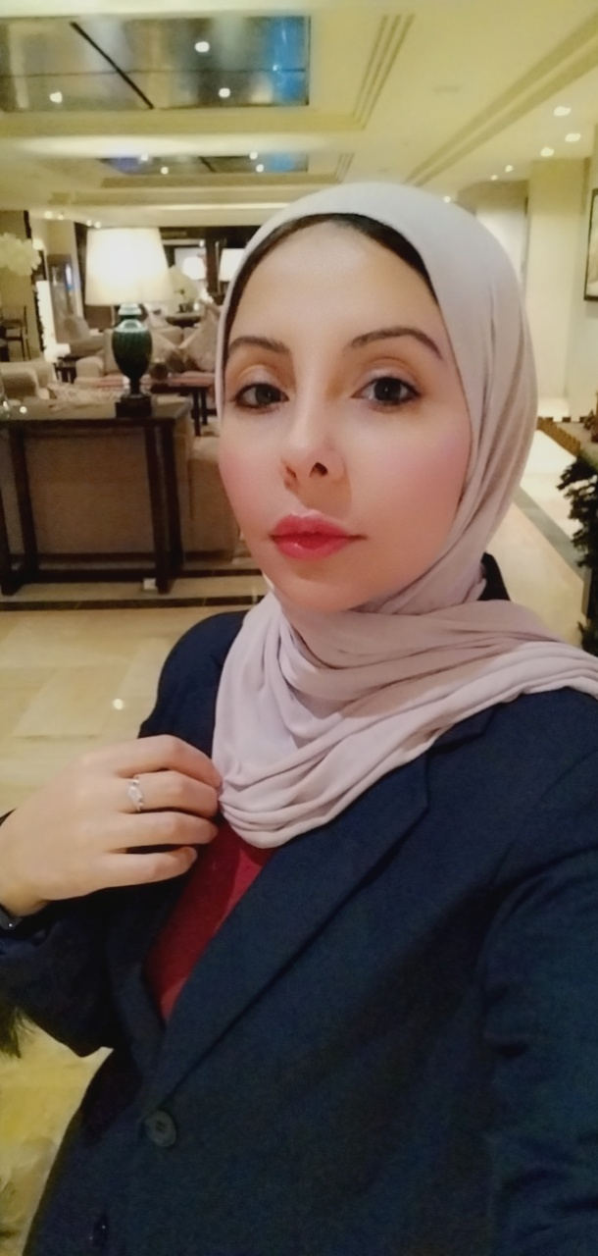

Personal Data:

Surname: Al-Smadi

First Name: Suhad Jameel Abdallah

Date/Place of birth 5th of May 1984 in Amman, Jordan

Marital Status: Single

Nationality: Jordanian

E-Mail: **lujaynjameel2014@gmail.com**

Phone: 00962-785345528

Education:

03. 2021 – 06 2023 Ammon Applied University, Amman, Jordan

Hotel Management

Awarded with **Bachelor of Hotel Management**

09. 2018 - 09 2020 Arab Community College, Amman, Jordan

Tourism and Hospitality

Awarded **Diploma** (Top of the Class)

03. 2015 - 06 2016 British Council, Amman, Jordan

English Training Course

Upper Intermediate Level

02. 2022 - 04 2022 IREX University

Global Solutions Conversions Program

Six-Week Virtual Training in Binationally Brainstorming Support for Increased Sustainability in Local Community

Awarded **Certificate**

Work experience:

10. 2022 – 01. 2023 Century Park Hotel, Amman, Jordan

Training in:

-Service

-Food & Beverages

-Reception

-Housekeeping

-Store Sale

Voluntary activities:

06.2019 - 09.2019 JRS Organization, Amman, Jordan

Humanitarian Refugee NGO

Fitness and Nutrition Tutor

Additional Qualifications:

Language Skills: Arabic - Mother tongue

English - Fluent

IT Skills: Awarded ICDL Certificate

Microsoft Office Word: Professional Level

Microsoft Office Excel: Professional Level

Microsoft Office Powerpoint: Semiprofessional Level