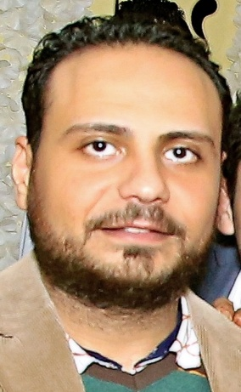

**Name : Sameh Zarif Thabet Loka .**

**Address : 4 El-Shahid Ahmed Badawy Street - El Makhbaz El Aly in Sohag .**

**Mobile Phone : 01272742784**

**Em@il :** [**SamehZarif@yahoo.com**](mailto:SamehZarif@yahoo.com) **.**

**Personal Data**

**Nationality : Egyptian . Date of Birth : 11/04/1990 .**

**Place of Birth : Sohag – Egypt . Social status : Single .**

**Military service : Finished military service .**

**Education**

|  |  |
| --- | --- |
| **Qualification** | **: Faculty of Commerce of Sohag University .** |

**Degree : Bachelor of Commerce .**  **Grade :** **Good.**

**Department : Accounting . Graduation Date : 2018 / 2019 .**

**Languages:**

**Arabic : Native Language . English : Good .**

**Experience**

* **Occupational Safety and Health Officer and Concrete Supervisor at Rolan Construction Company .**
* **Delivery representative at Mashaweer company .**
* **Sales representative at Free Food Company .**
* **Store keeper at King Cola Factory.**
* **Sales representative at Al-Hikma Pharmaceutical Company .**

**Computer Skills**

* **Very Good in Using Computer Programs and Internet.**

**Personal Skills**

|  |  |
| --- | --- |
| * **Self-Motivated.** | * **Able to work Under Stress.** |
| * **Public Management Skills.** | * **Creative.** |
| * **Able to work within a team .** | * **Quick Learner.** |
| * **Friendly .** | * **Helpful .** |

***Thanks for give me this chance***