**Zoubir Otmane** 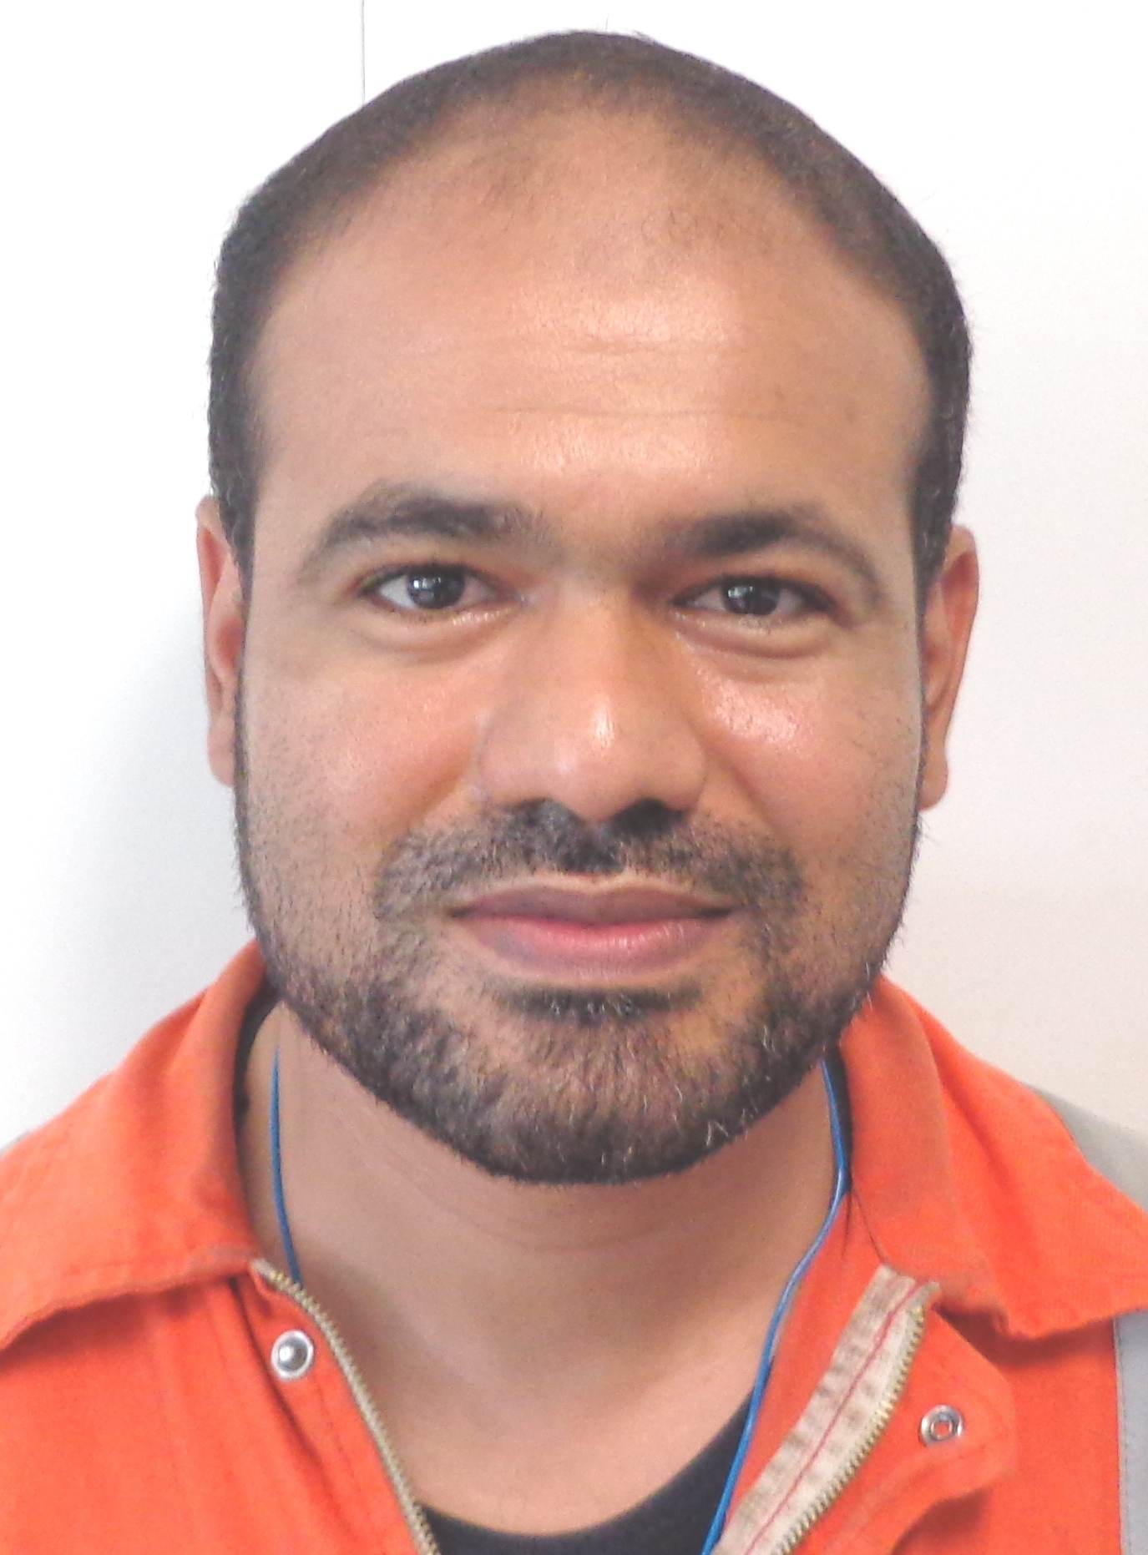

Mobile: +213-698-844851

[otmaz@yahoo.fr](mailto:otmaz@yahoo.fr)

**SUMMARY**

* Profile: Male, 45 , Married
* Nationality: Algerian
* Current position: Turbine Supervisor
* Company: Global petroleum services Project -Petromar MMO Sonangol Bloc 3-05 Angola
* Total Experience in Oil & Gas : 19 years

**Turbine Supervisor**

Maintenance supervisor with more than 14 years of experience in oil & gas industry onshore & offshore and 5 years as a **Turbine supervisor** carrying out safely the maintenance duties. I’m qualified to do the following :

* Operation, maintenance & troubleshooting of gas turbine aero-derivative RB211, LM2500, SGT100, MAN THM1304, Turbomeca turmogaz III E, borescope inspection, shaft alignment, overhauls.
* Preparing risk assessments for critical tasks such complex lifting, major rotating machinery overhauls
* Preparing detailed planning for major Maintenance activities
* Preparing permit to work , briefing on site, technical documentations, fault finding ,troubleshooting, technical investigation, technical reporting , lifting plans
* Good communication skills, leadership personality and team work.
* Dealing with vendors for remote and onsite support

**WORK EXPERIENCE**

* **Jul 2015 – Now Turbine Supervisor PETROMAR SONANGOL Block 03 offshore ANGOLA**
  + Plan, monitor & execute operations & maintenance on 3 gas turbines generator MAN THM 1304 and 3 Turbo pump type Turbomeca Turmogaz III E
  + Troubleshooting & preventive maintenance at 2000Hrs , 4000Hrs & 8000Hrs.boresope inspection, shaft alignment
  + Borescope inspection, turbine alignment, technical reporting.
  + SAP for maintenance activities, following and updating the PM, spare part , and correctives works

* **Jan 2012 – June 2015 Maintenance Rotating Machine TL BP Krechba , ALGERIA**

* + Plan, monitor, execute the maintenance activities for the rotating machines on all ISG facilities according to the highest safety, environmental, reliability and cost effective standards
  + Coordinate the major overhaul activities with vendor’s such Rolls Royce RB211, RT62 , GE Nuovo Pignone PGT25 (LM2500) , Siemens SGT100 , Turbo Expander
  + Facilitate teamwork in the team and between the different facility teams, facilitate and enable direct interface between Maint, Ops, Technical team, Engineers, project ext

**Jan 2011 - Dec 2011 Technical system Team leader BP Krechba , ALGERIA**

* + Technical system is a part of the technical team which is in charge of all the systems used in the JV such Maximo , E-warehouse, MOC’s , procedures , Documentum.

**Jun 2008 – Dec 2010**  ***Maintenance superintendent*  BP Krechba , ALGERIA**

* Lead the delivery of ISG Maintenance teams HSE performance targets
* Lead the Maintenance team to develop a high performance and competent training
* Safely deliver the maintenance tasks according to PM program and corrective orders
* Establish/control/evaluate maintenance contracts ensuring proper vendor assistance where needed.
* Prepare LCC & JOC letters for submittal as required.
* Act as CAM for maintenance support contracts. Monitor contract spending and seek LCC approval for . budget increases prior to overspend
* Risk assess, planning, and ensure necessary resources are available for the execution of all field-wide

Maintenance activities.

* **Jun 2006 - May 2008 *Head of maintenance supervisor*  BP Krechba , ALGERIA**
* Organize and supervise Krechba maintenance supervisors and Contractors to ensure safe, timely, and

execution of all plant maintenance and repairs work on Rolls Royce RB211 Gas Turbine generator, Mitsubishi compressor, atlas copco compressor..)

* Plan, accept and close out routine and breakdown work in the Maintenance Management System

(MMS) MAXIMO 6 with the assistance of a Maintenance Planner and Krechba Operation Supt

* Plan and coordinate all shut down maintenance activities.
* Risk assess, plan, and ensure necessary resources are available for the execution of all field-wide maintenance activities,
* Co-ordinate and prepare resources for execution of maintenance work
* Monitor and develop the skills and competencies of maintenance technicians by on the job coaching

and identification of training needs

* Participate in the Local Incident Management Team
* Oct 2003 - Apr 2006 ***Maintenance supervisor* BP Krechba , ALGERIA**
  + Plan, monitor & execute the maintenance activities on a gas engine motor (Waukesha), air compressor atlas copco , pump, Electrical motor.. ect
* Oct 2002 - Oct 2003 ***Maintenance supervisor* MI SWACO Hassi Messaoud , ALGERIA**
* Plan, monitor & execute the maintenance activities on a mud plant

**EDUCATION**

* **Diplomat of Electo- Mechanical Engineer** Sep 1994 - Jul 2000 **Hydrocabon university Boumerdes, Algeria**

*Subject: Reliability of high voltage power electrical line feeding a gas plant*

* **OTHER CERTIFICATES**
* 2015 Bosiet & H2S training Falck nutec Dubai
* 2013 Speedtronic MARK VI Maint GE training center ALgeria
* 2013 Centrifugal compressor IAP Algeria
* 2011 PGT 25 Aero derivative gas turbine Florence Italy
* **2010 Management and Leadership Level 2 &3 Hamsely Fraser ILM UK**
* **2009 Emergency Response Course Flack Nutec Risk& Crisis Mgt Norway**
* **2009 Practical Contract Management CP Training Consortium UK**
* **2009 High Voltage Operational Safety E.ON Engineering Academy UK**
* **2008 Manage Maintenance Function with Success CEGOS France**
* 2007 **Leadership skills training CESI France, Algeria**
* **2007 Investigation Root Cause Analysis Training BP Algeria**
* **2007 Sulzer Pump Technologies SULZER Pompes France**
* **2006 Hazardous Areas LCEI France**
* 2004 **Lifting asseseor and preparing lifting plan NSL , Algeria**
* 2005 **Scaffold inspector Rig blast, Algeria**
* **2004 Working with MAXIMO V4 MRO Software**

**IT SKILLS**

* **Windows & Office tools** Outlook Advanced, Excel, Word, Power Point , MS project , Visio
* **Operating systems, Networking & Hardware**
* Maximo V4 Advanced
* Maximo V6 Intermediate
* SAP

**LANGUAGES**

* Arabic Native
* French Fluent
* English Fluent

**References for Zoubir Otmane:**

**John Duffy**   
**Maintenance Superintendent**  
In Salah Gas, Algeria.  
Personal Email : [john.duffy@uk.bp.com](mailto:john.duffy@uk.bp.com)

'Kurt Ove Asheim'

**Maintenance Superintendent**  
In Salah Gas, Algeria.  
Personal Email : [Koas@statoil.com](mailto:Koas@statoil.com)