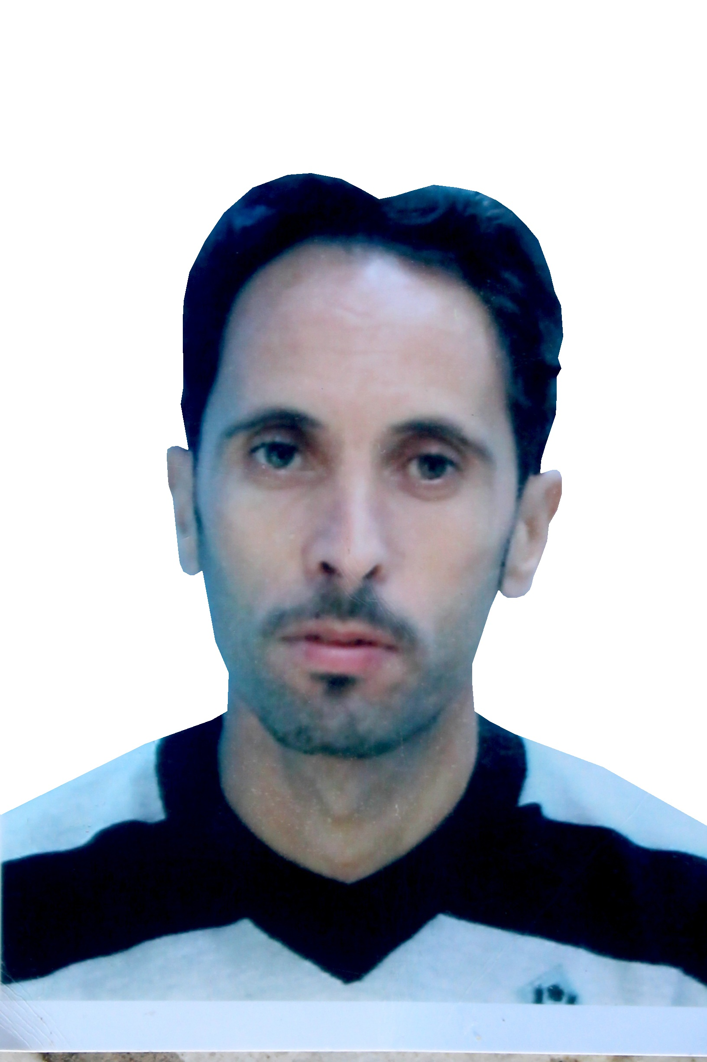

**CURRICULUM VITAE**

**The name : RIAD**

**First name : FERRADJ**

***AGE :43***

Nationality : ALGERIAN  
* 7 years security agent

*Driving license class B. C1

*2 years as a gardener and landscaper

familial status : married

**Number of Children: 3**

**educational level :** **Third year secondary**

**driving license: Light and heavy**

**Professional experience : 3 years in planting and mare trees and 6 months gardening**

**interest**

I am very interested in working in the field of agriculture, especially taking care of trees and nurseries. I also have experience in the field of picking and harvesting various fruits. Finally, please accept my utmost appreciation and respect.