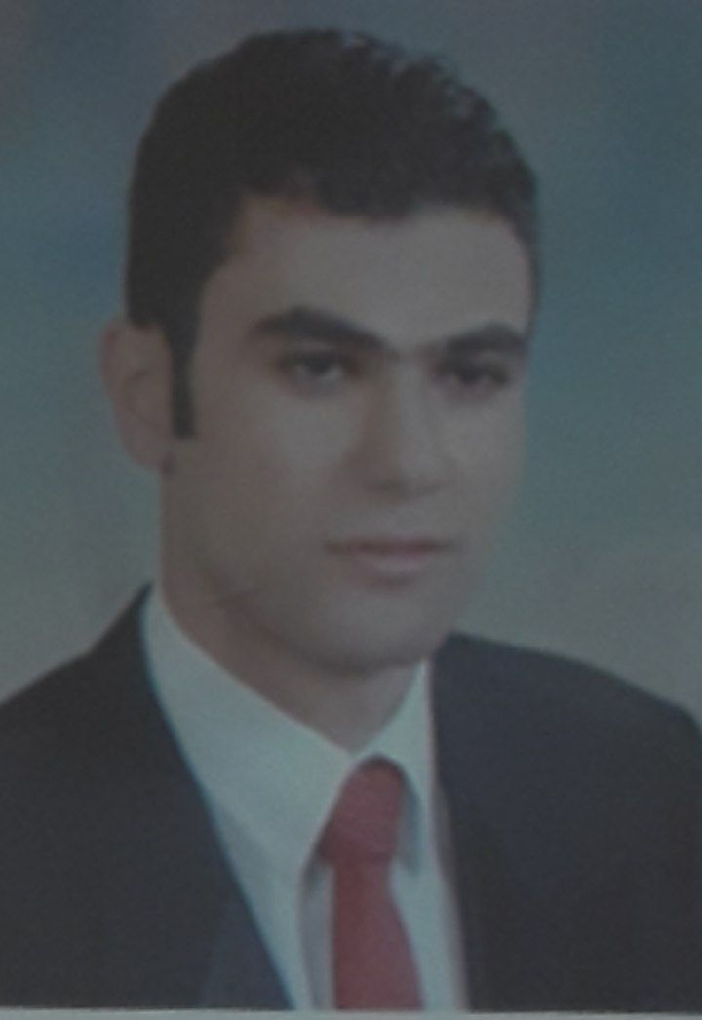
Curriculum Vita c.v

Name : Rami Eid Ibrahim
Nationality : Egyption
Birth date : 22 - 2 - 1985
Birth place : Cairo
Marital Status : Married
Education: Faculty of Law Ain shams university 2007

Experience :
1- Sales at sallab ( 2006 - 2008 )
2- Sales at mahgoob (2008 - 2013 )
ٍٍ Sales Supervisor at rashdan ( 2013 - Present ) -3
Duties include
*sales of bathroom accessories .
*sales Agent Ideal Standard.Gacub .Gawad Mixer and Grohe Mixer.
Lawer in Ahmed osman Office in Elkhalifa Almamon .-4
5- Sales experience certificate frome Grohe company .

Career ObJective:
Working In asingle team- the development of skills - abilities and
development of expertise- the ability to withstand work pressure-in addition to material gain .

Contact information :
E – Mail : ramym7543@gmail .com
Special tel : 01127641527

Address :
Al- Iman tower - Behind Khaldoun school Al shaarawi - shoubra Al khaymah second

