**C.V.**

Name : Asmaa Ahmed A. Mahmoud. 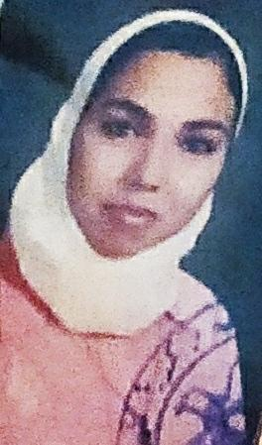

Mobile : 01025639857.

E-mail : asmaa.ahmed27887@gmail.com.

Address: 3 Alexandria matroh st. Elhanovil –El-Agamy.

**Personal Data:**

Date of Birth : 9 September 1987.

Nationality : Egyptian.

Gender : Female.

Marital Status : Married.

Religion: : Muslim.

**Academic degree:**

* Bachelor in Agricultural science, role May 2008, Alexandria University .
* Master's degree in Agricultural science, 2016 , Alexandria University – faculty of agriculture.
* Honors : (Excellent "B+"). GPA Total : 3.56 from 4.00.

**Career Objective:**

Seeking a good position in a respectable company where my educational background and interpersonal skills can be developed, where I could help people and make benefits for the company.

**WORK EXPERIENCE:**

Working At:

* E.J.S. Science Teacher from 25/9/2018 to 6/2021.
* AVANO pharmaceutical Company as a medical representative for cosmetics products in 2011.
* Walgreens pharmaceutical company as a medical representative for medicinal Products in 2012.
* The Advanced Animal Nutrition Laboratory as a chemist, Faculty of Agriculture, Alexandria University, Analysis, from 25/1/2016 to 9/2018.

**Computer Skills:**

* I have ICDL certificate degree Excellent.
* Very good in Windows XP - Windows 7, 8.
* Introduction in computer science (SQL database)
* Very good in Microsoft Office.
* Very good in Internet Use, Searching skills.

**Languages:**

**Arabic:** Native language.

**English:** I have a TOEFL certificate degree 426.

**Personal Skills:**

* Ability to leader of teams.
* Ability to work under pressure.
* Capable of working in teams.
* Ability to learn more in my field and other fields.

**Hope my Qualifications will meet your Requirements**

**Certifying that all data above are correct**

Asmaa ahmed